Instructions for using FGIBAVL & FGIBDST

Two screens are available for monitoring your account activity and checking account balances.

- FGIBAVL – Budget Availability Status Form provides summary information by a FOAPAL’s (term for account code) account pools. A new enhancement now provides an available balance drill-down option that lists unposted documents.

- FGIBDST – Organization Budget Status Form allows the user to select the FOAPAL in whole or segments to gather data. This screen also displays detail to the program code level and allows the user to drill down and see the documents associated with a particular account.

The major difference between the information presented in FGIBAVL and the information presented in FGIBDST is that the balances in FGIBAVL include all items entered into Banner even if they are not yet approved or completed. When looking at balances in FGIBDST they only reflect the items that have been completely approved and processed. For the most part these two forms will not agree. To see the actual amount of dollars available, FGIBAVL is the better screen to review; however, FGIBDST has more detailed information.

Login to Banner.

To access a screen in Banner you can enter the screen name in the direct access box or select the screen name from your personal menu.

On the GUAGMNU Screen example below, in the Direct Access Box type FGIBAVL and hit enter.

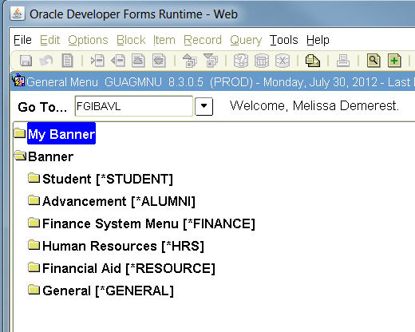

Budget Availability Status Form - FGIBAVL

The FGIBAVL form will show an Organization’s pool budget balances. The fields used to access your information are:

Chart: Required one digit chart of account code
1 = University 2 = Foundation
Fiscal Year: Required two digit fiscal year
Index: Not used leave blank
Commit Type: Required set to both

FOAPAL: Fund: Required
Organization: Required department code
Account: Required
Program: Required

Once the desired FOAPAL is entered select the next block button or Block/Next from your drop down menu to view the results of your inquiry. Error messages appear at the lower left hand corner of the screen if any field data entered is invalid.

Tip: If you enter A00 as the account, even though the fund does not have an A00 budget, it will search from the beginning and will bring up all pool budgets that are associated with the rest of the FOAPAL.

The following information will be displayed:
Account: pool account
Title: description-pool budget account
Adjusted Budget: original budget and any budget adjustments
YTD Activity: expenses
Commitments: requisitions/purchase orders
Available Balance: amount of funds available
Pending Documents: checkbox indicators identify pending documents

A total line is also displayed with totals for all accounts within the FOAPAL.
If more accounts are used within the FOAPAL than will fit on the view display a scroll bar will appear on the right of the display box. Scroll down to view accounts.

Reminder: FGIBAVL reflects all transactions processed in Banner both completed and in process.

Sample Budget Availability Status Form

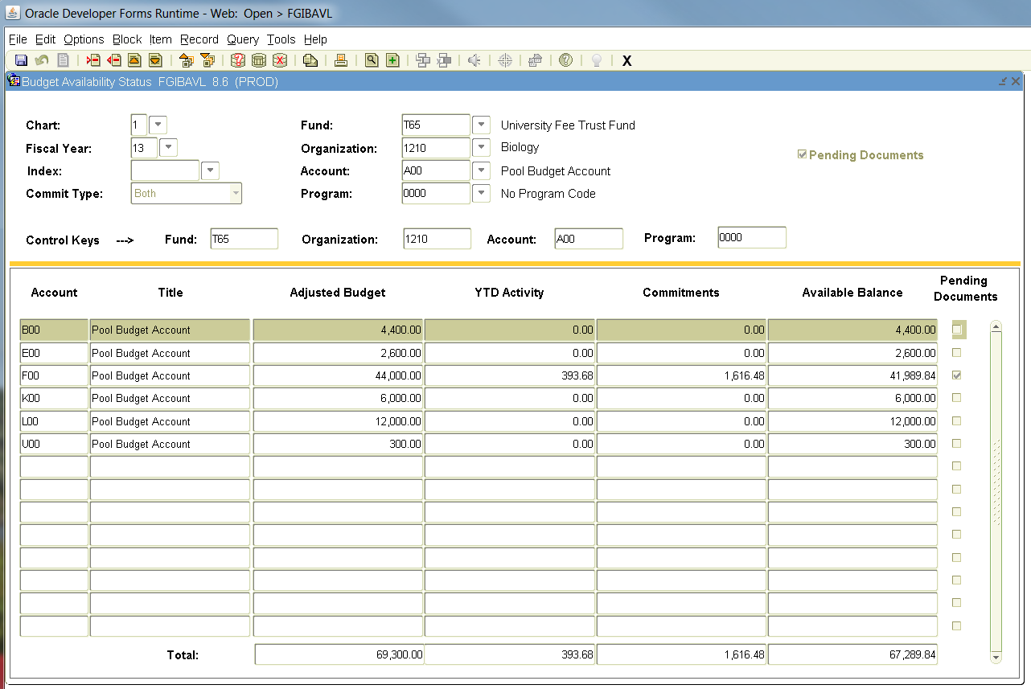

Sample Budget Availability Status Form - Pending Documents Drill Down

In the upper right corner a check mark will appear in the box next to Pending Documents if there are pending documents.

To view pending documents select an account row with the Pending Documents indicator checked.

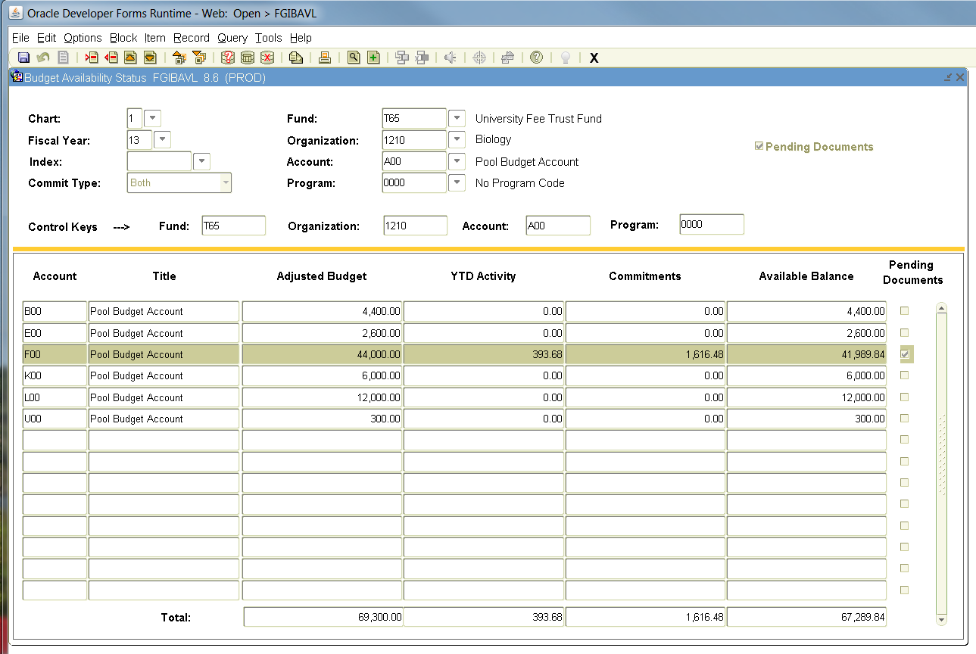

Then select Options on the main tool bar and choose Pending Documents. You will be able to view unposted documents affecting available balances.

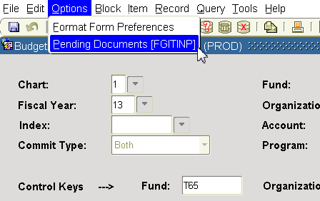

The status field will indicate the status of the document. For example, incomplete, pending approval, etc.

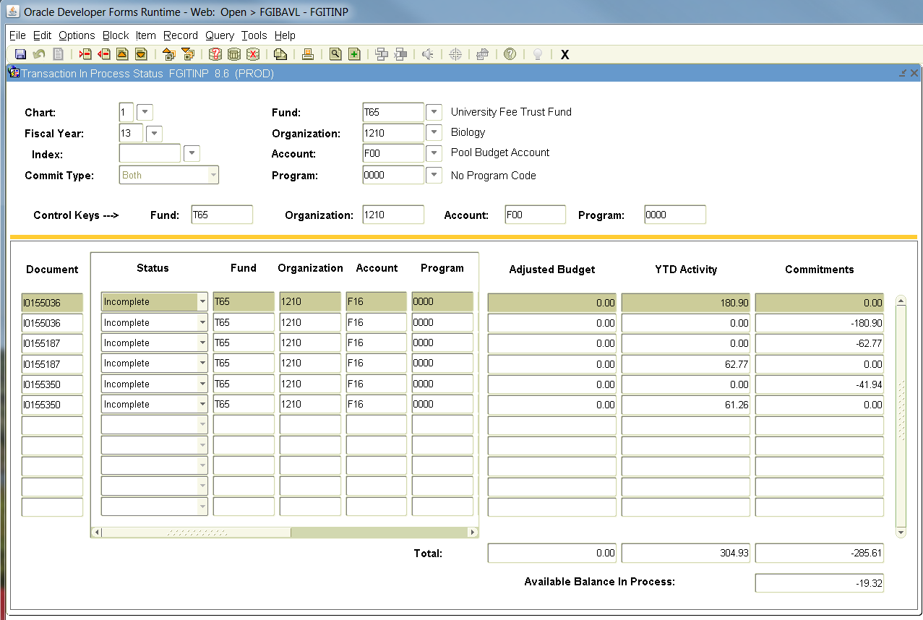

Use scroll bar to see description.

Organization Budget Status Form – FGIBDST

Login to Banner. On the GUAGMNU Screen in the Direct Access Box type FGIBDST and hit enter.

The FGIBDST form allows the user to select the FOAPAL in whole or segments to gather data. This screen also displays detail to the account code level and allows the user to drill down and see the documents associated with a particular account. The fields used to access your information are:

Chart: Required one digit chart of accounts code
1 = University 2 = Foundation
Fiscal Year: Required two digit fiscal year
Index: Not used leave blank
Commit Type: Required set to both

FOAPAL: Organization: Optional department code
Fund: Optional
Program: Optional
Account: Optional
Acct Type: Leave blank
Activity: Leave bank
Location: Leave blank

Two check boxes are on the key data selection screen: Query Specific Account and Include Revenue Accounts. To query a specific account check the Query Specific Account box, fill in the first four parts of the FOAPAL, and that is the only account that will show on the screen. To view revenue check the Include Revenue Accounts box and leave the account code blank; if you do not want to view revenue accounts uncheck the box.

Not all segments of the FOAPAL are needed to view your accounts. If left blank, it will collapse all your FOAPAL information.

Once the desired FOAPAL or segment of FOAPAL is entered, select the next block button or Block/Next from your drop down menu to view the results of your inquiry.

Error messages appear at the lower left hand corner of the screen if any field data entered is invalid.

The following information will be displayed:
Account: pool account
Type: account type
Title: description
Adjusted Budget: original budget and any budget adjustments
YTD Activity: expenses
Commitments: requisitions/purchase orders
Available Balance: amount of funds available.

A total line is also displayed with totals for all accounts within the FOAPAL. If more accounts are used within the FOAPAL than will fit in the view display a scroll bar will appear on the right of the display box. Scroll down to view accounts.

Next Block

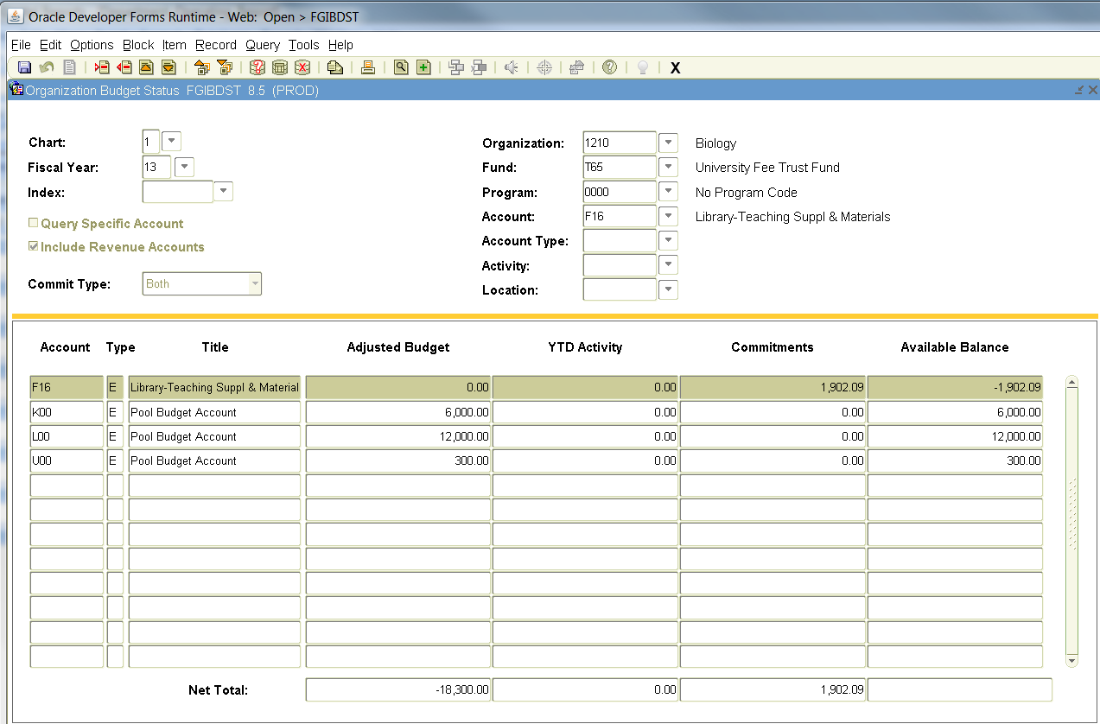

To view specific parts of an account enter the appropriate part of the FOAPAL and select the next block button. For example, to view a particular Program you need to enter that Program in the Program box. When leaving any of the first four blocks empty, Banner will automatically collapse the part of the FOAPAL that is left blank. The last three blocks for Account Type, Activity and Location are not needed.

In the example below Fund T65 and Organization 1210 were selected. The information that appears is specific to T65-1210 but all Program and Account information is collapsed.

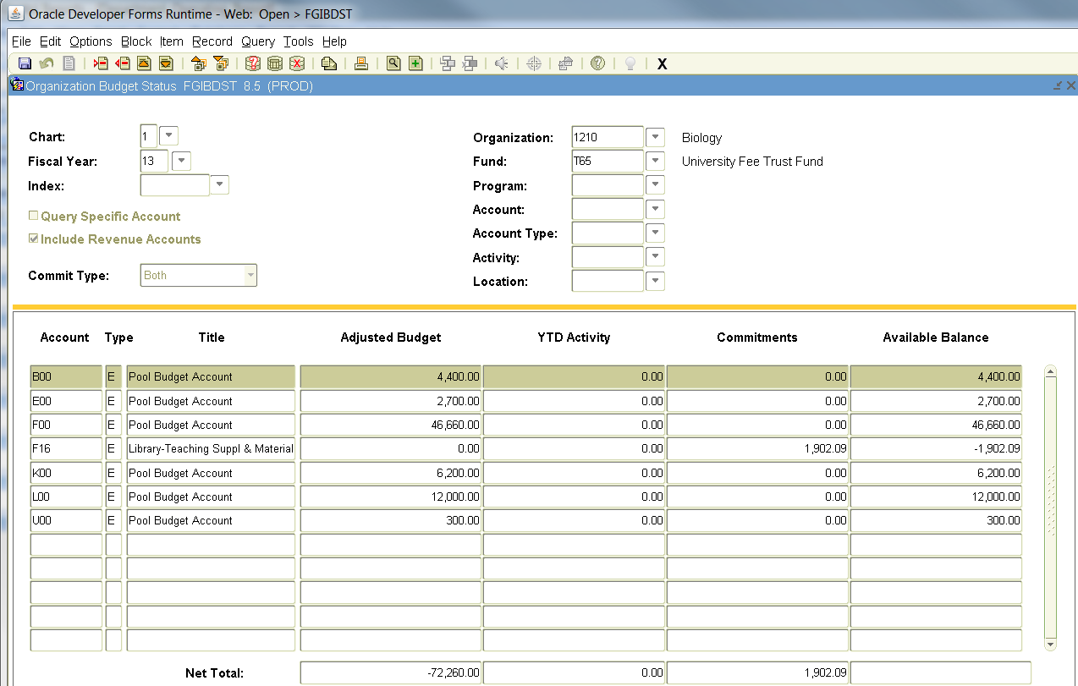

The Available Balance column calculates for any activity within a particular Account Number. A calculation of the available balance by pool account can be done by entering a query - select the Enter Query button on the top of the form, then type the desired pool letter followed by the % sign, (i.e. F%) then select the Execute Query button.

Enter Query
Execute Query

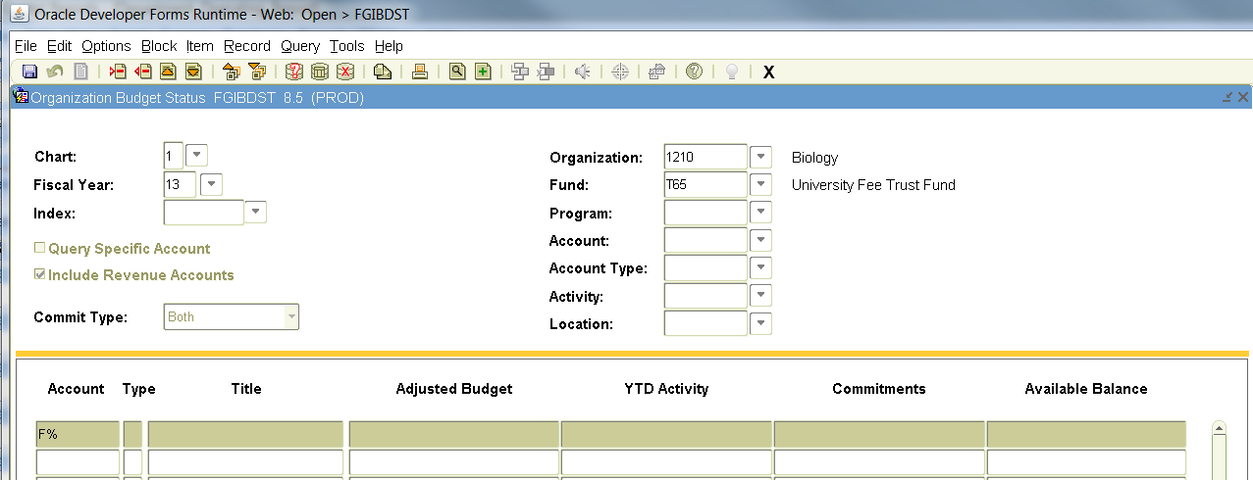

Banner will display all activity for just the F accounts. To get the balance remaining in the F’s you need to subtract the YTD Activity and Commitments from the Adjusted Budget. Or you can go to the FGIBAVL screen and the activity information and remaining balance will show under the Pool Account.

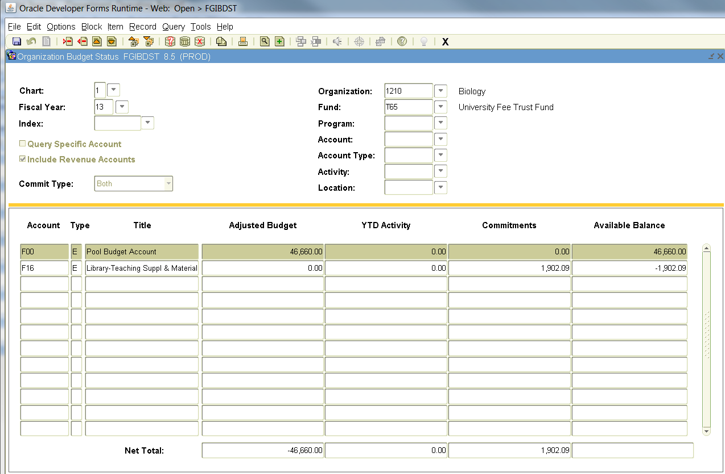

Budget Summary Information:

To view the activity and balance for a particular Fund and Organization enter the desired information in the FOAPAL blocks, select the next block button, then select Option on the main tool bar and then select Budget Summary Information. The screen will display the Adjusted Budget, YTD Activity, Commitments and Available Balance broken down between Labor and Direct Expenditures. If you have Revenue for the Fund that was selected this information would be included also. Because this form calculates information that may not be accessible to the user it may not be beneficial to work with the Budget Summary Information.

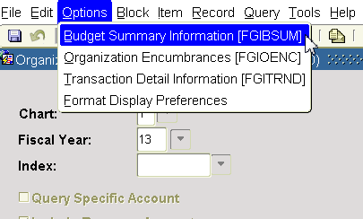

Information will display as below:
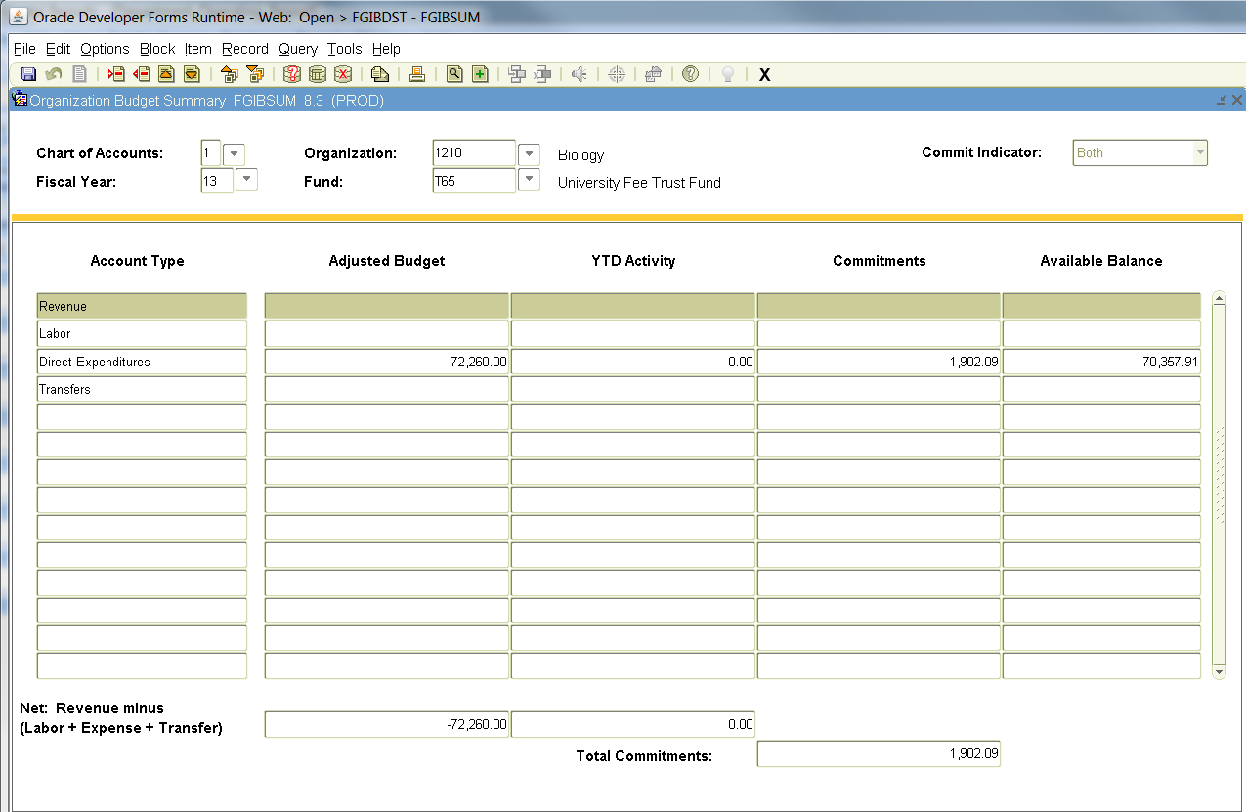
Drilling Down on Balances:

To view the documents that make up the budget information, the YTD activity or the Commitments highlight the appropriate box and select Options from the main tool bar, then select Transaction Detail Information.

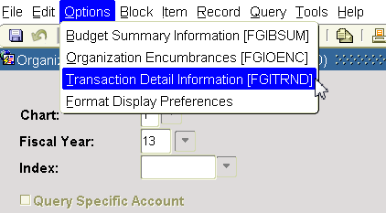

This screen allows you to view more information such as the description used for a transfer and the remaining part of the FOAPAL. Use the scroll bar at the bottom of the screen to view the additional information.

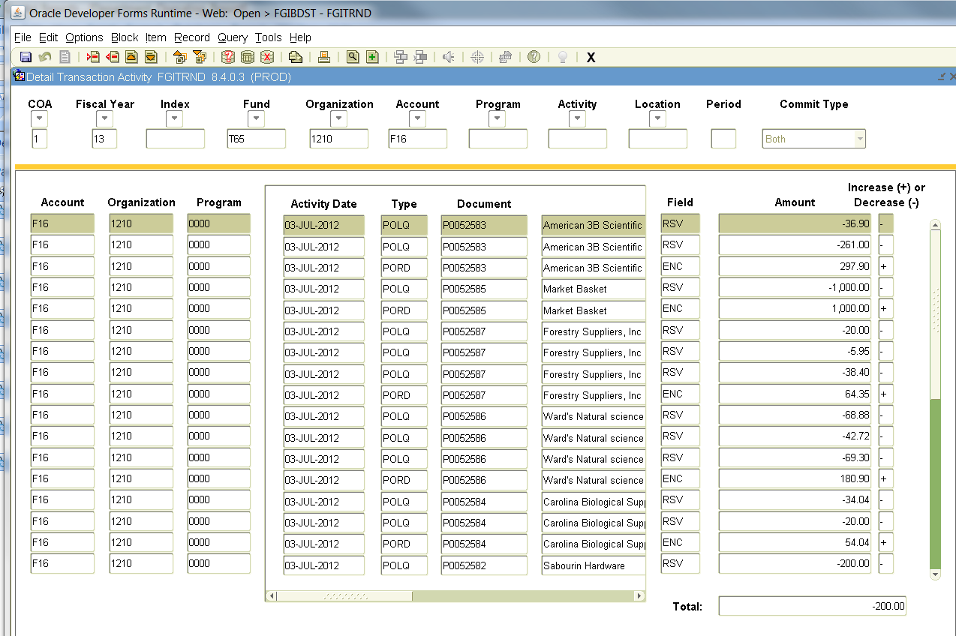
From this screen you can drill down on the actual document. Highlight the Account line that you wish to view (the cursor must be in the Account, Organization, Program, or Type Box, it does not recognize the rest of the fields when trying to do the query), and then select Option on the main tool bar and then choose Query Document.

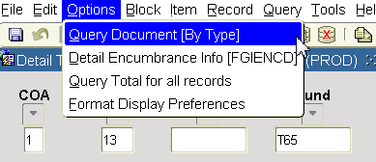

The Document Number will appear. Then select the Next Block button to scroll through the document (depending on the type of document there can be several pages of information). Simply continue selecting the Next Block button to view the pages.

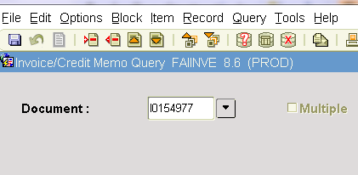

You would follow the same pattern to view a Purchase Order and/or an expense.

The FGIBDST Form contains a lot of information and users will find, through practice, what is the best way to request the information that you desire. The above instructions are not inclusive of all scenarios, but are an attempt to get you familiar with how this dynamic form operates.

Below is a listing of Keystrokes that can be used instead of the Banner buttons on the menu bar.

FUNCTION KEYSTROKE PURPOSE

Clear Form/Rollback Shift – F7 This would be used to get back to the top
of the Form.

Next Block Ctrl – Page Down This would be used to move to the next
section of the form.

Happy Bannering!!!!!!!

