Adding a New Advisee to an Appointment Campaign
Click on the campaign that you wish to edit:
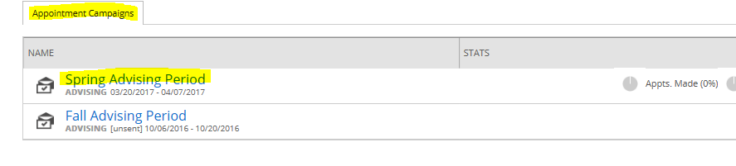
Select Edit Campaign Details from the right menu:
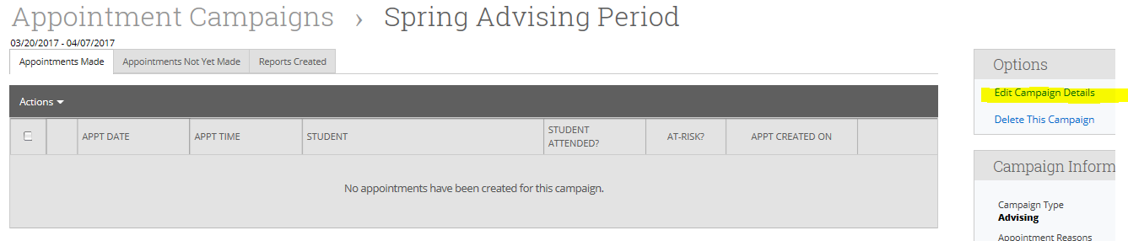
Select Edit from Student Select:
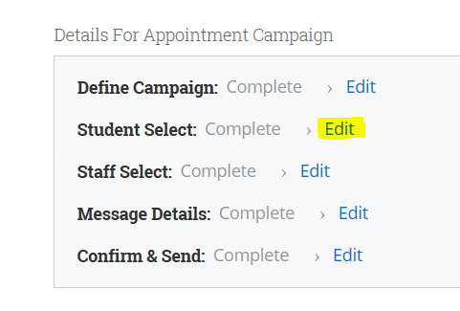
Click Add More Students from the bottom:
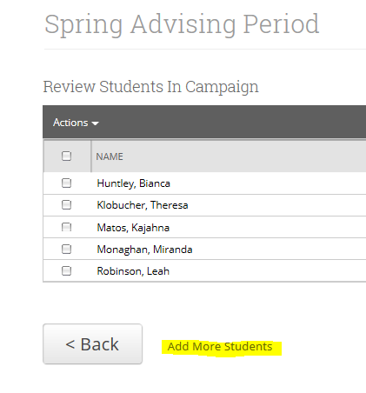
Select Invite All My Assigned Students. The new advisee will appear in the list. Click on the student that wish to add and hit Continue. Continue to the Confirm & Send page and hit Send. Select Invite Only New Students:
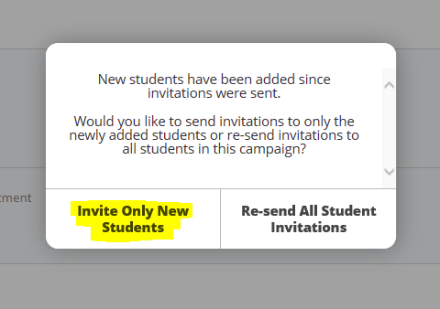

This will send the invitation to only the new advisee(s) that you selected.

