Tracking Your Appointment Campaigns
You can monitor your Appointment Campaigns by selecting Campaigns from the left hand navigation menu and then selecting the Appointment Campaigns tab:

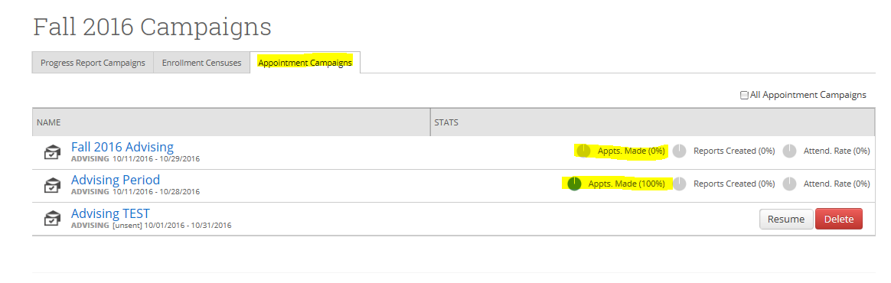
You will quickly see the progress on your campaigns. You can then drill down into a campaign by clicking on the Name of the Campaign:

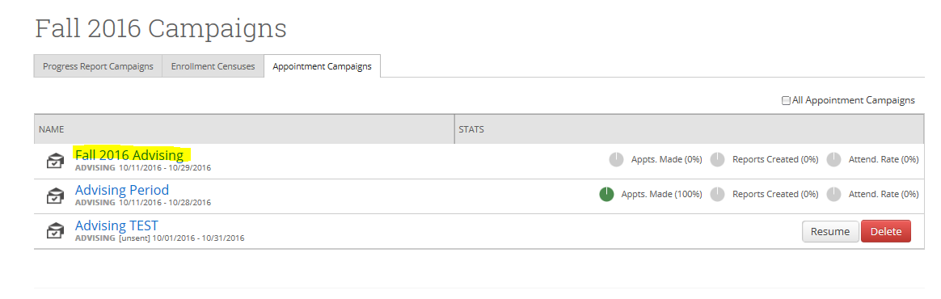

You will see the Appointments Made tab and can also select the Appointments Not Yet Made tab to view the students who have not yet responded. Click on the Actions down arrow for a list of options. You can Resend Appointment Requests as many times as you like during the campaign:

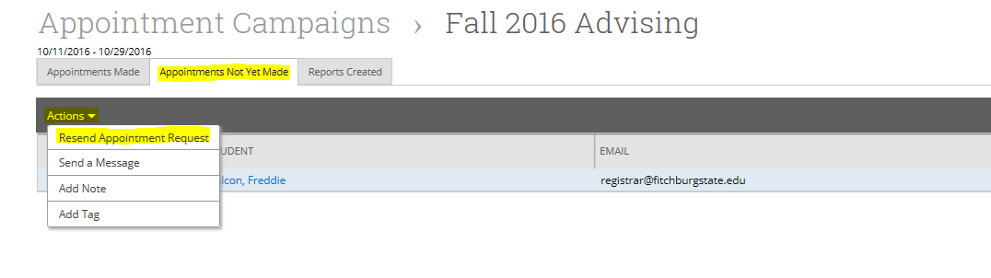
Prior to resending the campaign invitation, you can add a comment:

