Fitchburg State University
Campus Climate Survey – 2018
Students, n= 258
Faculty and Librarians, n= 103
Staff and Administrators, n=143

Part I: Welcoming Environment

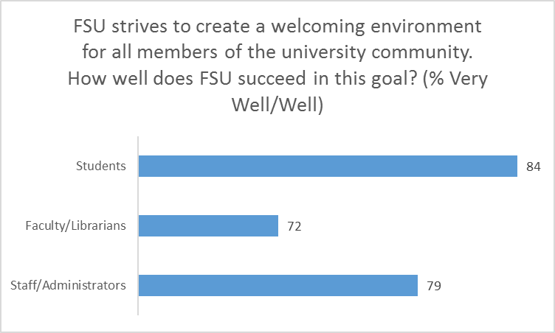
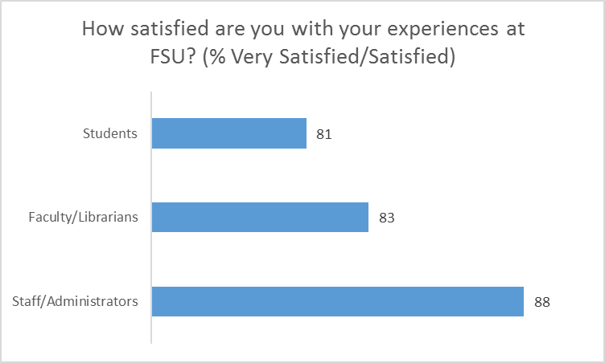
Part II: Diverse Relationships

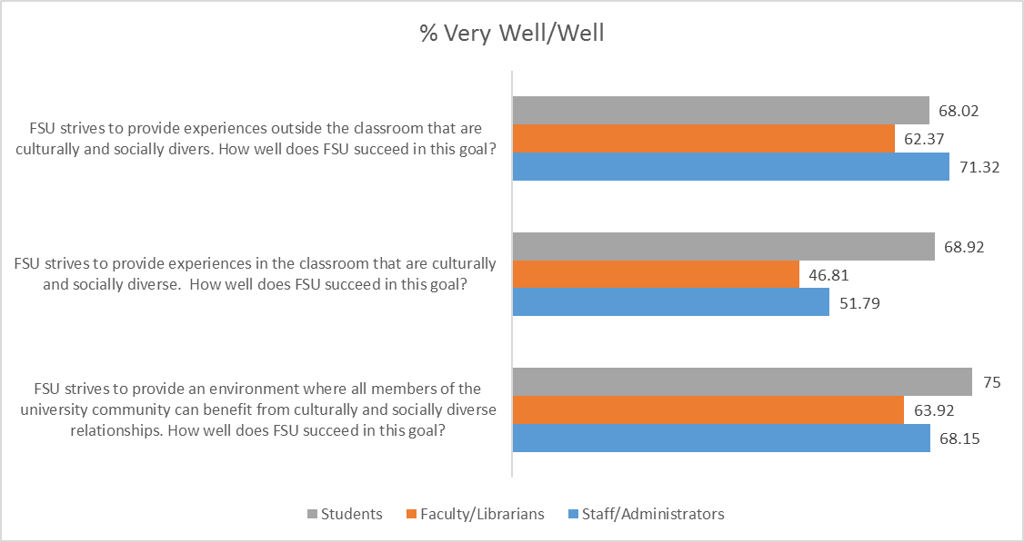
Part III: Inclusive Diversity

This chart is composed of questions only asked of Faculty/Librarians and Staff/Administrators:

