Amelia V. Gallucci-Cirio Endowment
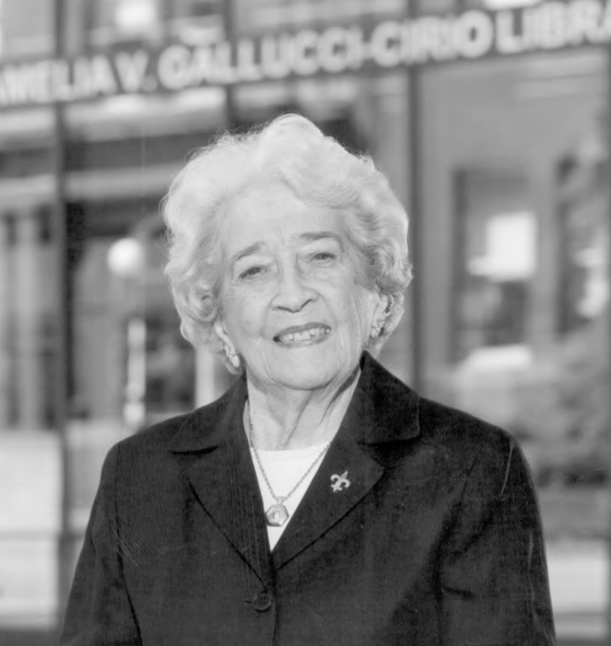

Proposal Guidelines and Application Form

Established in September 2002
PRIMARY PURPOSE
To sponsor faculty teaching and student learning
to perpetuate and further Italian language and culture.
SECONDARY PURPOSE
To sponsor lectures, symposia, and foreign travel by faculty and students.
To sponsor cultural affairs and other activities that can help faculty, students,
and the general public to achieve a better understanding of the Italian language and culture
through the history, literature, art, and philosophy of Western Civilization.

Office of the Provost and Vice President for Academic Affairs
Fitchburg State University, 160 Pearl Street, Fitchburg, Massachusetts 01420

Amelia V. Gallucci-Cirio Endowment (est. 2002)

Proposal Guidelines
Through a generous donation of $1,000,000 from the late Amelia Gallucci-Cirio, Class of 1938, the Fitchburg State University Foundation, Inc. established an endowed fund to provide support for activities and projects that promote Mrs. Gallucci-Cirio's long-held interest in the study of Italian language, culture, and Western civilization. Each year, net earnings (after fees) produced by the endowment will be available to support projects that conform to the following guidelines established by the endowment agreement.

PRIMARY PURPOSE: To sponsor faculty teaching and student learning to perpetuate and further Italian language and culture.

Educational materials to support the study of Italian language, Italian culture, and Western civilization in the classroom or other venue.

Study grants or scholarships for study in the U.S. or abroad: support for students or faculty to take classes in Italian language; support for faculty or students to pursue academic studies of Italian culture and Western civilization; support for scholarly work in Italian Studies and Western civilization; support for visiting professorships at Fitchburg State; or supplemental funding for Italian language instruction at Fitchburg State.

SECONDARY PURPOSE: To sponsor lectures, symposia, and foreign travel by faculty and students; to sponsor cultural activities that can help faculty, students, and the general public achieve a greater understanding of Italian language and culture through the history, literature, art and philosophy of Western civilization.

- Center for Italian Culture (CIC): support for programs or activities sponsored by the CIC.
- Cultural programs: support for cultural programs and activities related to Italian language and culture including, but not limited to, literature, history, art, and music.

FINAL REPORT
All Amelia V. Gallucci-Cirio awards require a final report to be submitted within six months of completion of travel. Recipients will be asked to submit a final report narrative and status of project outcomes. Recipients may also be asked to present on their research to appropriate local audiences, as well.

FREQUENTLY ASKED QUESTIONS

- Can the scholarship be applied to anything? No, it must be applied to projects related to the goals of the Amelia V. Gallucci-Cirio endowment.

- What is the amount of a scholarship? Amounts vary according to the proposals, but can range from $100 and up, distributed over the spring semester.

- Is the content of the application important? Yes; scholarship applications are reviewed by the selection committee and evaluated on the basis of clarity, relation to the mission of the endowment, and commitment to submit a final report after project completion.

The Amelia V. Gallucci-Cirio Endowment Grant Application
Proposal Instructions

STEP 1 - Complete Cover Page with Title and Abstract (not included in page limit)

Proposal Cover Page

Name of Principal Investigator:_______________________________________________

Co-Principal Investigator(s):___________________________________________________________

Department(s):____________________________________________________________

Main Contact Information:

Email: _______________________________________________________

Telephone: ____________________________________________________

Proposal Title:

Abstract (No more than 100 words that concisely summarize the proposal).

If your project involves travel to do interviews and/or archival research in another language and you do not speak the language, please indicate how you will accomplish the outcomes of your project:

STEP 2 – Write and attach a project narrative with the following information (3-page maximum).

The narrative should be concise but include sufficient information to permit effective review by a multi-disciplinary group. Language should be non-technical in nature. Be specific and informative; avoid redundancy. All narratives must include the following sections:

- Background and Significance—
  - Clearly state your view of the proposed project’s significance.
  - Briefly sketch the background of the present proposal including any previously- performed related research and its outcomes or findings.

- Goals and Objectives—
  - List your broad, long-term goals (including professional development goals), and
  - Explain how the grant will enhance your research or professional development.

- Description of Project—
  - Describe the project (if the project includes scholarship in terms of research and/ or creative endeavor describe the methodologies and procedures to be used or activities to be engaged in to accomplish your specific objectives).
  - Provide a tentative sequence or timeline with critical events and discrete phases of the project, if possible.

STEP 3 – Complete the following project budget (not included in page limit)

The project budget must include all anticipated expenses. All amounts should be rounded to the nearest dollar.

EXPENDITURE CATEGORIES | Requested Funds | Other Funds(Cash or in-kind) | TOTAL

PERSONNEL

STIPENDS
STIPENDS

NON-PERSONNEL

TRAVEL (for project)
PROJECT SUPPLIES
EQUIPMENT
OPERATIONS
Other (specify)
TOTAL BUDGET

Include Budget Notes here. These should provide supporting details for all budget items. Show how particular amounts were calculated. Reference your use of continuing scholarship, department, or funds from any other source.

STEP 4 – Submit proposal

The corresponding proposal format and accompanying materials must be submitted electronically to: ProvostGrants@fitchburgstate.edu no later than 5 p.m. on October 15, 2021. A selection committee comprised of the university's chief academic officer, chief development officer, Dean of Arts and Sciences, chair of the Department of Humanities (or designee), Academic Coordinator of the Center for Italian Culture, and the Dean of Graduate and Continuing Education, shall review all proposals. To be considered, proposals must use the correct proposal cover and budget sheets and must include the appropriate narrative.

Stipends —Summer stipends are intended to provide research assistants with resources to support their time during the summer. Supplies —These are consumable items required to carry out the project. Equipment —Requests for equipment, books, computer software, or similar items. Operating Expenses —These include expenses for surveys (including paper and postage), off-site facility costs, housing and other items typically treated as direct costs, as well as refreshments or other costs associated with meetings that may be part of the project. Research Travel —Travel monies should be requested only for travel that is directly related to the proposed project and that would not ordinarily be covered from the departmental or university budget.

