 | Tied to Program Mission/  Professional Standards | Worded as a statement of intent | Focused on student learning | Focused on program VS course | Not bundled | Uses a verb that matches domain and level | Can be observed/  assessed  Quantitative/  qualitative | Accurate Brief Concise | Potential to inform program improvement?
PLO 1

PLO 2

PLO 3

PLO 4

PLO 5

PLO 6

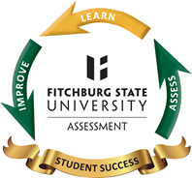

Worksheet 2: Program Learning Outcomes Checklist

Does the overall list of outcomes cover multiple learning areas? Yes or No

