Date: September 18, 2020

To: Fitchburg State University Community

From: Michael Nosek, Professor of Biology and Chemistry
Kisha Tracy, Associate Professor of English Studies
Co-Chairs of All University Committee

Re: All University Committee (information on AY21)
_______________________________________________________
The All University Committee (AUC) had its initial organizational meeting convened by President Lapidus on Thursday, September 10th. Members of the AUC for the academic year 2020/2021 are:
1. Laura Bayless (Vice President for Student Affairs)
2. Catherine Canney (Secretary) (Associate Vice President for Academic
Affairs)
3. Alberto Cardelle (Provost & Vice President for Academic Affairs)
4. Joseph Cautela (Treasurer of SGA)
5. Rala Diakite (Humanities)
6. Sara Levine (Psychological Science)
7. Christa Marr (Economics, History, & Political Science)
8. Kerry McManus (Vice-Chair) (SGA President)
9. Michael Nosek (Co-Chair) (Biology/Chemistry)
10. Steve Olson (SGA Student Trustee)
11. Charles Roberts (Communications Media)
12. Daniel Sarefield (Economics, History, & Political Science)
13. Kisha Tracy (Co-Chair) (English Studies)
14. Amy Wehe (Mathematics)

The purpose of this memo is to explain some of the functions and procedures of the AUC. Please feel free to contact one of us (mnosek@fitchburgstate.edu, 978-665-3430, or ktracy3@fitchburgstate.edu, 978-665-4827) with any questions regarding the AUC for this academic year.

This document covers in detail the procedures involved in submitting a proposal as well the procedures that a proposal goes through to be passed. For those of you who have submitted before, there are a few changes this year. Additionally, there will be some new processes for submissions that will involve the two-year rollout of the new Liberal Arts and Sciences (LA&S) curriculum.

The AUC will host a workshop as part of the upcoming “Understanding and Implementing the LA&S: A Conversation Series” sponsored by the CTL. Please look out for more details on the remaining events in the series.

Conversation 1: Building the New Curriculum – The Pathway to LA&S Course Approval
Tuesday, September 29: 3:30-5:00 (via Google Meet, information to follow separately)
Facilitators: Elizabeth Gordon, Charles Roberts, Kisha Tracy
Want to know more about how the new LA&S program is designed and works together as a whole? Want to walk through the new AUC forms to put through a course? Want to know what the AUC committees will be looking for in new and revised courses? In this session, we will discuss, share information on and workshop the next steps in the LA&S implementation process, which includes the submission of AUC course proposals that address how we will teach and communicate the program's learning outcomes, with the goal of developing a shared understanding of the larger curricular picture into which specific LA&S courses fit.

The remainder of this document covers the AUC proposal procedure.

The All University Committee
The description, duties, and responsibilities of the AUC and its subcommittees are detailed in the Agreement between the Board of Higher Education and the Massachusetts State University Association (the so-called Faculty or MSCA Contract). The AUC at Fitchburg State is comprised of eight faculty/librarian members elected by the faculty body, three administrators appointed by the President, and three students selected by the Student Government Association. The standing sub-committees of the AUC are the Curriculum Committee, Academic Policies Committee, and Student Affairs Committee. Proposals submitted to the AUC are generally referred to one or more of these subcommittees for deliberation and recommendations. The AUC then deliberates on the proposals and forwards its recommendations to the President of the University. (In addition to the AUC and its three standing subcommittees, there are approximately 21 additional ad hoc and special University-wide committees on our campus.)
In AY19/20 academic year, a new subcommittee was formed within the Curriculum Committee (comprised of members of the Curriculum Committee). The LA&S Subcommittee meets outside of the regular Curriculum Committee to review proposals seeking the designations created under the new LA&S system. That subcommittee makes recommendations to the full Curriculum Committee for their consideration.
Any member of the Fitchburg State community may submit proposals to the All University Committee. The AUC requires specific forms for each kind of proposal. The most recently revised electronic versions of the blank forms are available at: https://www.fitchburgstate.edu/academics/academic-affairs/shared-governance/all-college-committee/. (Note: Forms for requesting LA&S designations under
the new LA&S system have been posted along with a set of Guidance Documents for each of the designations.)
Please note that all curricular proposals require a review by the appropriate departmental curriculum committee(s), department chairperson(s), and academic dean(s).
AUC Proposal Submission Procedure
The web page for the AUC is https://www.fitchburgstate.edu/academics/academic-affairs/shared-governance/all-college-committee/. There, you will find all of the required forms for AUC proposals, minutes from past AUC meetings and its subcommittees, and meeting calendars of the AUC and its standing subcommittees. This page also includes the AUC/ACC (the former All College Committee) archives dating back to 1979.
The AUC proposal process is entirely paperless. Proposals forms are available in both PDF and Word formats. These are both editable documents. Proposals may be submitted in either format using these editable documents. Please do NOT send scans of paper documents. Also, names of chairs and deans are sufficient to signify that they have been informed of, and have reviewed the document, but signatures are not necessary.
NEW THIS YEAR: all AUC proposal forms should be submitted through a Google form, rather than via the AUC webpage or by email. The link to submit is here: https://forms.gle/wJDFbhxEYDUU6Lu48 (can also be found on the AUC website). Each proposal will be assigned an AUC proposal number and will be posted on the AUC website (proposals for this academic year (2020-2021) will be found under year "2021").
Proposals received by 5:00pm on the Friday prior to a scheduled AUC meeting will usually be taken up by the AUC for referral to appropriate subcommittee(s) at the next scheduled meeting. Please check the AUC website for your proposals and make a note of the proposal number(s). Proposals will be accepted throughout the year and will be deliberated by the AUC and subcommittees on a continual basis. The final submission deadline for AUC proposals for the 2020-2021 academic year is Friday, March 26, 2020.
Special Note Regarding LA&S Courses
This year the University will continue a two-year roll-out of the new LA&S system. The proposal that was passed through the governance process and approved by the President can be found as proposal AUC 60 for AY19.
An implementation committee has been formed by Academic Affairs, and AUC co-chair Kisha Tracy will serve on that committee. In an effort to balance the need to continue the roll-out as well as implement a process that is manageable for all, we will be pursuing the following plan.
Roll-Out Plan:
There is a concern about the work, including how the cognitive and emotional loads of faculty and peoples’ ability and time to be creative is in short supply in this period of COVID/new modalities. Respecting these considerations, the roll-out plan for LA&S in terms of course approval will include:
- making the Foundations for Lifelong Learning the first priority this year (though any proposal for any learning outcome in LA&S may be developed and submitted to AUC at any time)
- then prioritizing the revision of existing LAS courses that map easily to the new curriculum
- dedicating summer 2021 for funded work to create new courses for all sections of the curriculum, but particularly in the remaining Critical and Creative Thinking across the Disciplines and Integrating and Applying LA&S Learning outcomes.
- earmarking the following academic year (2021-2022) for the creation of more new courses with more emphasis on Critical and Creative Thinking across the Disciplines in the Fall and Integrating and Applying LA&S Learning in the Spring.
We will be reaching out to the Deans, Department Chairs, and the Curriculum Committees of each department, and providing assistance, as we move forward with this process. Throughout this process, we will welcome constructive feedback and suggestions, and we will deal with individual concerns as they arise. We ask for your patience and cooperation during this significant transition.
AUC Proposal Deliberations
After a proposal has been received by the AUC, it is referred to the appropriate standing subcommittee(s). AUC agendas will be emailed to the campus approximately one week prior to an AUC meeting. Sponsors do NOT need to be present at the AUC meeting at which a proposal is referred to the subcommittees. However, you should check the AUC website for information regarding which subcommittee(s) has received your proposal(s).
A proposal will first be taken up for deliberation at the subcommittee level. Subcommittee agendas will be emailed by the subcommittee chairs approximately one week prior to their meetings, so please watch for your proposal(s). The sponsor(s) or an authorized representative(s) should be present for subcommittee deliberations of your proposal(s). Proposal deliberations may result in suggested amendments to the original proposal. The subcommittee(s) will record their votes and approved amendments in their minutes, which will then be forwarded to the AUC chairs by the subcommittee chairs.
At this point, the proposal will be considered and deliberated by the AUC. Again, the sponsor or an authorized representative should be present for AUC deliberations of your proposal(s). The AUC reserves the right to propose the addition of new amendments or remove amendments proposed during subcommittee deliberations. Final versions of proposals will be sent to the President for approval. In the case of a new academic program, final approval rests with the Massachusetts Board of Higher Education.
Sponsor Responsibilities
Sponsors should actively track the progress of their own proposals through the governance system. Sponsors do not need to attend AUC meetings at which referrals to subcommittees will be carried out. However, sponsors (or their designee) will need to attend all subcommittee and AUC meetings at which their proposal is being reviewed.
During the processes of subcommittee and AUC deliberation, amendments may be made to original proposals. The amendments are documented in the minutes of these meetings, and are recorded on the AUC proposal site. These are proposed amendments and may be changed or removed by the AUC as part of its review process.
Our AUC proposal site includes detail about the progress of a proposal through the governance system. The site provides information about the subcommittee(s) to which a proposal has been referred and on what date, as well as the actions taken and amendments made to proposals. When visiting the AUC proposals site, please be sure to scroll to the right-hand side to view all activity related to a proposal.
Viewing Submitted AUC Proposals
All proposals for this year are available for viewing on the AUC website (http://www.fitchburgstate.edu/auc or, alternatively, https://www.fitchburgstate.edu/academics/academic-affairs/shared-governance/all-college-committee/). Next, click on the "Visit the AUC Proposal Submissions webpage ..." link and then enter the year 2021 (see image below). You may also filter the proposals by subcommittee as well.
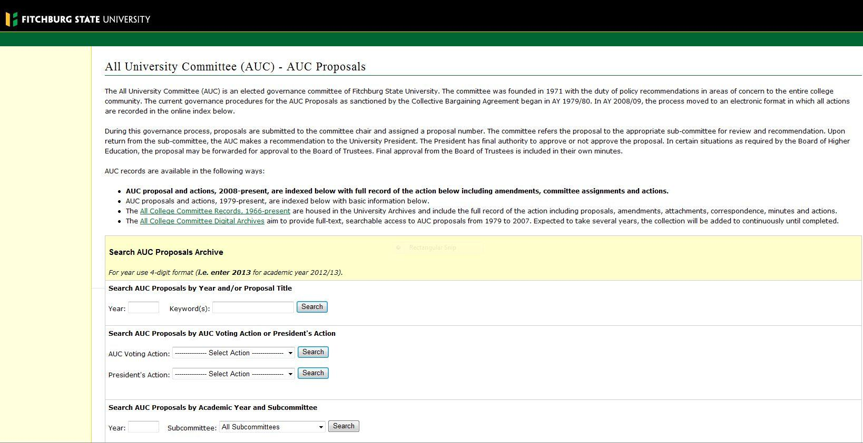
Once you enter the year and/or which committee(s) you want, the proposals will be available for viewing. To view a proposal, simply click on the proposal you wish to view. Please note that proposals do not open in a new window, so you will need to use the "back" arrow to return to the proposal submissions page.
The AUC proposal site includes details about the progress of a proposal through the governance system. The site provides information about the subcommittee(s) to which proposals have been referred, referral dates, as well as the actions taken and amendments made to proposals. When visiting the AUC proposals site (pictured below), please be sure to scroll to the right-hand side to view all activity related to the proposal.
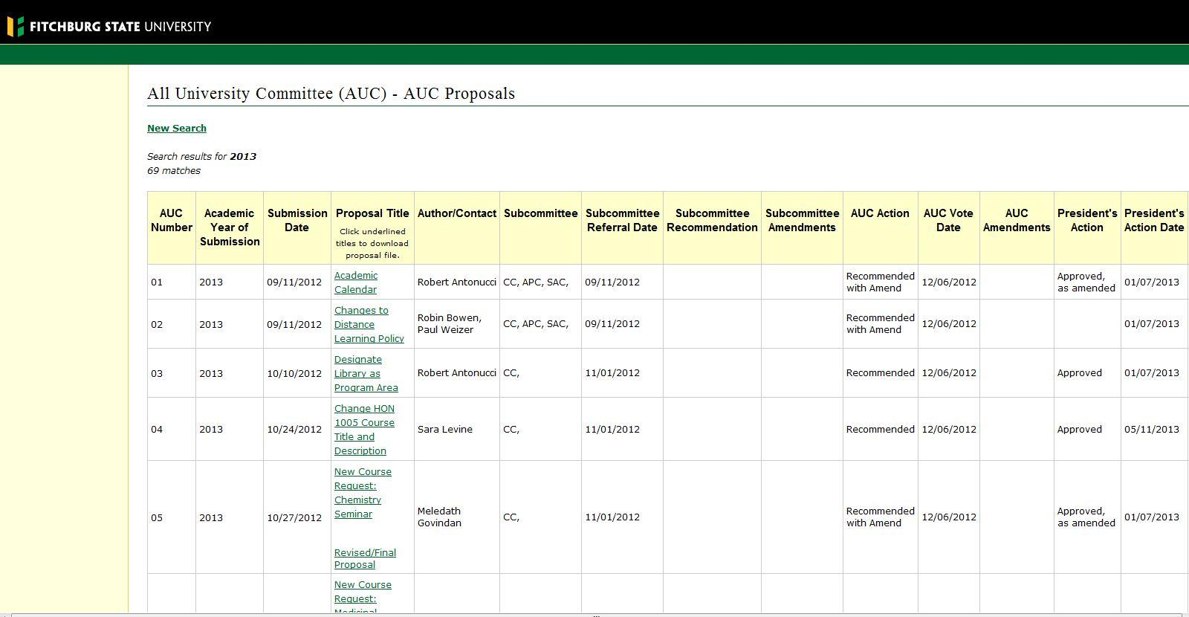
Explanation of the Required AUC Forms
Please be sure to use the most current proposal forms, which are available on the AUC website http://www.fitchburgstate.edu/offices-services-directory/academic-affairs/all-college-committee/. These forms have been updated for the current academic year, and proposals should be made on the current forms. Proposals submitted on older versions of the forms will be returned to the sponsor(s).
Please note that signatures are not required on the forms, but all forms submitted for curriculum changes (including new program proposals) must be reviewed by the department's curriculum committee, department chair, and appropriate dean, and must include 1) the results of the department curriculum committee vote, 2) the name of the chair of the department curriculum committee, 3) the name of the department chair, and 4) the dean. Proposals lacking the appropriate information will be sent back to the sponsor without being assigned a proposal number.
AUC Proposal Form
This form is used for AUC proposals with the exception of a new course, LA&S designation requests, and new academic program proposals. Any proposal except new courses or programs should use this form.
AUC New Course Request Form and Liberal Arts and Science Cluster Approval Form
The New Course Request form is used for all new courses being submitted for consideration. (You do not need to attach an AUC Proposal form when submitting a course request.) If you are requesting LA&S designation(s) for an existing course or a new course, the Liberal Arts and Sciences Cluster Approval Form must be submitted.
Cluster designation requests are considered by committee as separate actions from new course requests when both are being requested.
Special note for LAS requests: If you submit a new course proposal and wish to have LA&S designations, you may still request the LAS designations under the current system (SMT, CTW, ART, etc) with the current form. (Students entering the University will continue to use the current LA&S system until the newer system is fully implemented.) If you also wish to have LA&S designations under the new system, that will require 1) an additional proposal using the newer forms, or 2) inclusion of both request forms with the New Course Proposal.
AUC New Program Proposal Form
This form is used for requests for new majors, minors, concentrations (tracks), and certificates. If new courses will be needed for a new program, separate New Course requests (and LA&S approval requests) should be submitted separately and prior to the proposal for the new program. The new courses need to be approved first before the new program can be considered. (It should be noted that new programs cannot be acted upon if they contained "non-existing" courses.)
Schedule of Meetings for the All University Committee 2020-2021
Below is the AUC schedule, and the schedules for other governance committees are also available on the AUC website. All meetings for AY20/21 will be held from 3:30-5:00p (except where noted below) and will be held remotely using GoogleMeet. The meeting link and the agenda for the meeting will be sent to the community several days before each meeting.
Fall Semester | Spring Semester
Tuesday, September 10, 2020 | Thursday, February 4, 2021
Thursday, October 1, 2020 | Thursday, March 4, 2021
Thursday, November 5,2020 | Thursday, April 1, 2021
Thursday, December 3, 2020 | Thursday, May 6, 2021
 | Wednesday, May 12, 2020 (2:30-4:30pm)
 | Thursday, May 13, 2020 (2:30-4:30pm)

