SSC Campus Quick Start

Start on the log-in page https://fitchburg.campus.eab.com

NEW: Your user name is your full Fitchburg State email address (e.g. JDoe12@fitchburgstate.edu).

Your password is your Falcon Key (network) password. (This will automatically update as you update your Falcon Key password with the university. You cannot change your SSC password while in the advising platform.)

- Login issues: contact ssc@fitchburgstate.edu

You will now be logged into your Advisor Home page which will display your list of advisees.

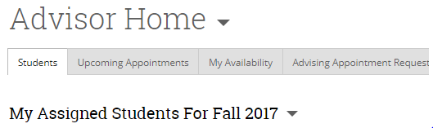

If you have more than one role, you will see a down arrow which you can click on in order to access your other home page(s.) The Professor Home page will display your courses and the students in those courses.

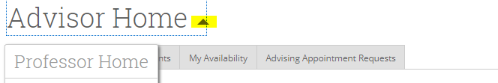

Click on the Actions down arrow to access functionality related to each tab.

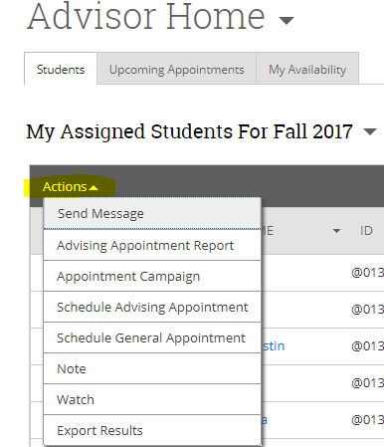

Throughout the site, blue text represents active links. Click on the name of an advisee in order to access the student information page.

The left hand navigation bar will allow you to access other functionality, such as Watch Lists and Saved Searches, as well as the Search functionality.

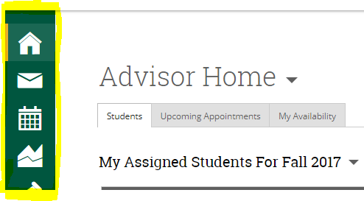

Help:

Access the Help Center by clicking on the ‘?’ in the upper right hand corner of your Home page.

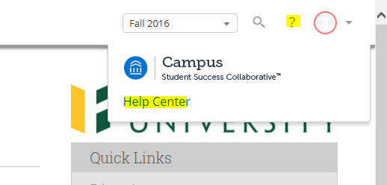

Here, you will find videos and tips for navigating the system.

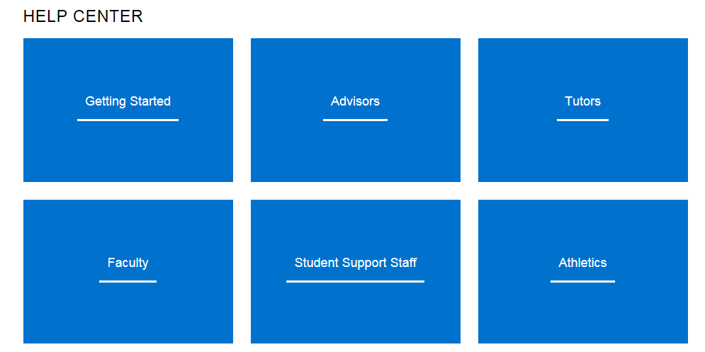

More Information?

Return to the SSC Campus Resource page: http://www.fitchburgstate.edu/offices-services-directory/institutional-research-and-planning/student-success-collaborative/

Questions or Issues?

Contact ssc@fitchburgstate.edu or Pam McCafferty at x3435 or pmccafferty@fitchburgstate.edu

