Identifying Your First Generation Advisees in SSC
Select the Search icon from the left hand navigation menu and then click the Show Advanced Filters box in the upper right corner. Open the Student Information section and select First Generation Students from the categories list:

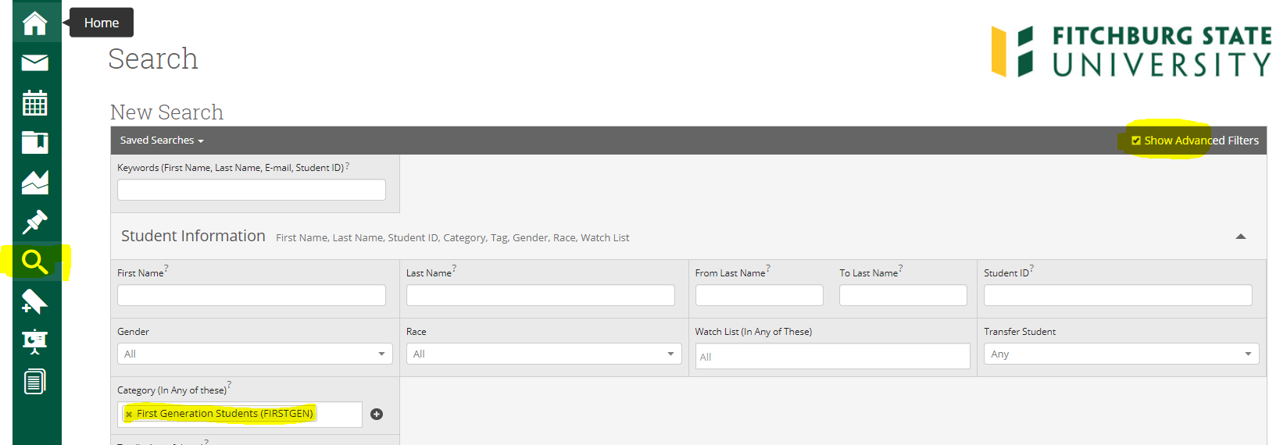
Scroll down and click the My Students Only box and then click the Search button:
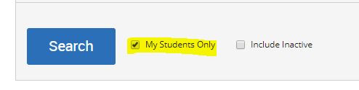
Once you have your search results, you can email your students or launch a campaign by selecting the Actions button and the corresponding action:

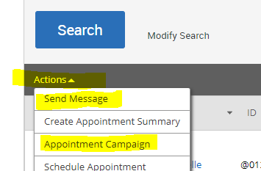

Also, when you are in an individual student’s record, on the Overview tab, you will see First Generation Student under Categories if the student is first generation:
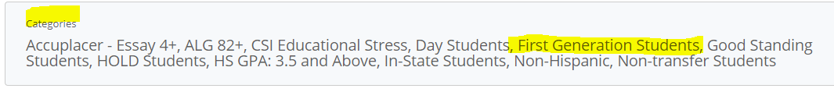

Note: Please be sure to select the correct term before beginning your search if the term has not yet begun:

