SSC Advising Tips: March 2020
Send a Text (or Email) to a Student:
Select Message Student from the right hand navigation menu. You will then see the option to either email or text the student.
[Note: SSC uses the cell phone number on file for the student in Banner.]

Send a Text (or Email) to Your Class Roster(s):
From your Home page, switch to your Professor role by clicking the small black arrow adjacent to Staff Home and select Professor Home:

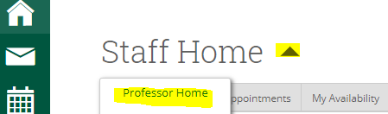
You will then see Students In My Classes. Select the students that you wish to contact by checking the box to the left of the student name. You can select all but clicking the box at the top of the column. You can also sort by course if you wish. Then under the Actions, select Message Student and you will be given the option to Text or Email the selected students.

Check your Calendar Sync Status:
Select the Calendar icon from the left hand navigation menu. Click on the Settings and Sync button in the upper right hand corner (under the Fitchburg State logo.) If your calendar is synced to your Google calendar, SSC will display Last Sync and the date and time. If it does not display this message, you can click the options to sync to Google. For step by step instructions: https://www.fitchburgstate.edu/offices-services-directory/institutional-research-and-planning/student-success-collaborative/

Update Existing SSC Appointments to Google Hangouts
If your SSC calendar is synced to Google (see above), your SSC advising appointments will be showing in Google calendar. In order to update these appointments to conferencing, open your Google calendar, edit the event, select Add Conferencing/Hangouts Meet on the left and then add the student via Add Guests on the right. Google will then send the student an updated invitation with the correct Hangouts link.

Questions? ssc@fitchburgstate.edu

