Syncing with Google for SSC

Go Select the calendar icon from the left hand navigation menu and then select the Settings and Sync icon in the upper right hand corner

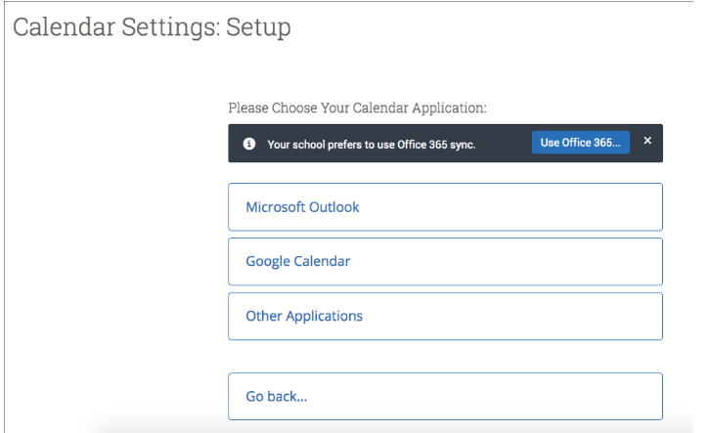
this will take you to the Calendar Settings page. Click Google Calendar from the list.

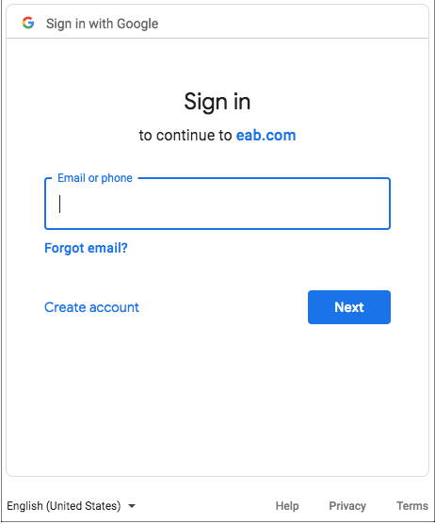

You will be taken to a Google sign-in page.

Enter your email and password to complete the sync setup.

You will then be redirected back to the Navigate Calendar page, and prompted to finish setting up your calendar. Choose one of the following options:
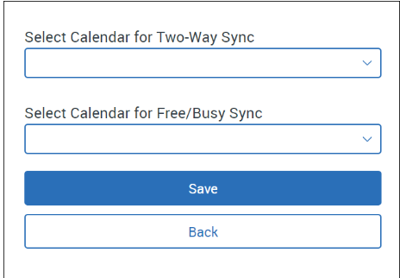
- Select Calendar for Two-Way Sync (Recommended Option): All calendar items will sync back and forth between your Navigate calendar and your professional calendar (i.e., Navigate calendar ↔ professional calendar). Events from your professional calendar will display as "Busy" in your Navigate calendar. Limited details from Navigate will display in your professional calendar.
- Select Calendar for Free/Busy Sync: Choose this option if you only want events from your professional calendar to display as "Busy" on your Navigate calendar (i.e., professional calendar ↔ Navigate calendar).
Once you have selected the appropriate calendar, hit Save and your sync is complete, with information about their sync on display.

