

**Ann Hyland Zimmerman Irish Culture Endowment**

(Established April 1998)

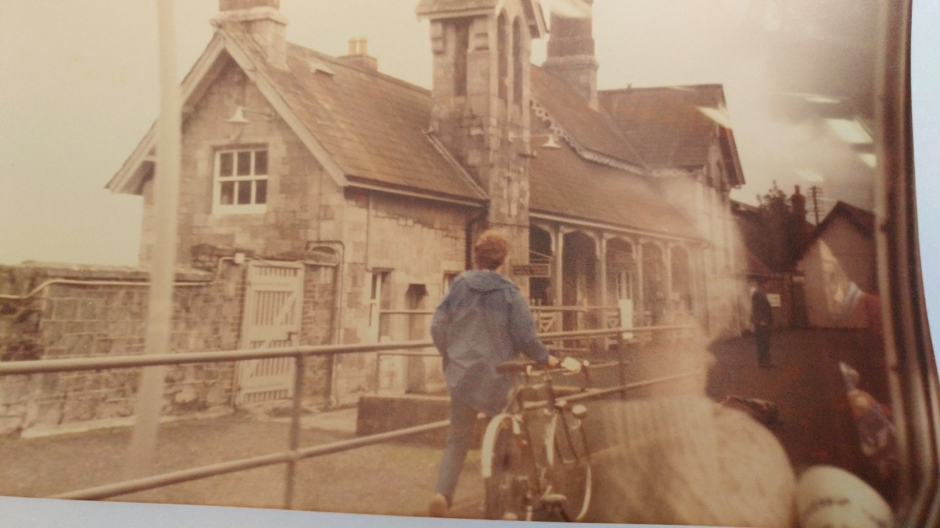

*Ann Hyland Zimmerman pictured in reflection of window pulling into train station in 1984*

**Proposal Guidelines and Application Form**

**Call for Proposals**

**The Ann Hyland Zimmerman Irish Culture Endowment**

Established by Ann Hyland Zimmerman, class of 1938, with the goal of perpetuating the Irish culture that was so vibrant in Fitchburg in the 1940’s and 1950’s. This award is intended to foster the understanding and perpetuation of Irish culture and its impact in Fitchburg and the surrounding area. The ideal award would go to applicants who embrace the criteria below:

**Purpose:**

The purpose of this fund is to promote an understanding and appreciation of Irish history, arts and culture at Fitchburg State. This can be accomplished in the following ways, but not limited to:

* Faculty research on Irish studies
* Faculty-led short-term study abroad opportunities for students
* Support student research on Irish history, immigration etc.
* Possibly link this fund with other organizations (Irish Consulate in Boston, etc.) or institutions (other universities with existing Irish Studies programs) on programming with shared costs
* To support Irish cultural events, where any entertainment would need to be related to Irish culture and history, not just influenced by
* To study the impact of Irish immigrants in the immediate and extended area of North Central Massachusetts
  + the Irish Mindset
  + their commitments
  + what they left behind
  + how they assimilated to the area

**Preference:**

Preference will be given to applicants/candidates who demonstrate the potential to have the greatest impact on maintaining and fostering an appreciation of Irish culture in the Fitchburg area.

**Criteria/Restrictions:**

* Awards are administered and recipients are selected by the Academic Affairs Division
* Award amount is based on annual earnings as determined by the Fitchburg State University Foundation, Inc. spending policy.

**Submittal:**

Proposals should be sent to the office of the Provost and Vice President for Academic Affairs, Fitchburg State University, 160 Pearl Street, Fitchburg, MA 01420; via e-mail to [jrivard@fitchburgstate.edu](mailto:jrivard@fitchburgstate.edu)*;* or by fax at (978) 665-4715.

**October 31, 2019** — Proposals Due

**Ann Hyland Zimmerman Irish Culture Fund 2019 - 2020**

**Application**

1. Name(s) of project leader(s) Affiliation with Fitchburg State

_______________________________________ ______________________________________

_______________________________________ ______________________________________

1. Describe the project or activity (300 words or less) and provide an estimated timeline for completion of the project.

_________________________________________________________________________________

_________________________________________________________________________________

_________________________________________________________________________________

_________________________________________________________________________________

_________________________________________________________________________________

_________________________________________________________________________________

1. Describe how the project/activity supports the mission of the Ann Hyland Zimmerman Irish Culture Fund (200 words or less).

_________________________________________________________________________________

_________________________________________________________________________________

_________________________________________________________________________________

_________________________________________________________________________________

_________________________________________________________________________________

_________________________________________________________________________________

1. Describe the intended outcome of this project and how it will benefit Fitchburg State, its students and the community.

_________________________________________________________________________________

_________________________________________________________________________________

_________________________________________________________________________________

_________________________________________________________________________________

1. What are the roles of the participants?

_________________________________________________________________________________

_________________________________________________________________________________

1. Where will the activity/activities be held (please indicate all of the dates related to the project).

_________________________________________________________________________________

_________________________________________________________________________________

1. Please provide a list of all partners in the project including their financial, in-kind or other commitments.

_________________________________________________________________________________

_________________________________________________________________________________

_________________________________________________________________________________

_________________________________________________________________________________

1. Please provide a detailed budget. The budget should include all information needed to assess the appropriateness of the expenditures, such as information on the agency, course catalogue information, or prices for items from vendors.
2. Indicate total cost of the project.
3. Specify approved additional funding sources as well as amounts received.
4. Specify any additional funding source requests being made.
5. Indicate amount of funding requested through the Ann Hyland Zimmerman Irish Culture Fund.
6. Advise if the project will move forward with or without funding from this endowment.

­­­­­­­­­­­­­­­­­­­­**Other items to be addressed in the budget may include the following:**

1. Travel
2. Tuition/fees
3. Scholarship/grant
4. Supplies/materials (itemized budget) *
5. Equipment (itemized budget) *
6. Stipends for instruction
7. Other: _____________________

* *Items purchased under these categories become property of the university.*

**NOTES:**

1. All funded projects must complete spending between Nov. 1, 2019 and Oct. 31, 2020.
2. Receipts must be submitted within two weeks of the completion of the project or no later than Oct. 31, 2020.
3. Applicants cannot receive funding in *consecutive* years.