Google Meet and SSC
Remote Access:

When you set up an advising campaign in SSC, your appointments will sync with your Google Calendar but it will not override any existing appointments on your calendar. If you are interested in meeting remotely, you must open the event on your Google Calendar and add Google Meet video conferencing. You will then save the event so the student receives the link on their side.

Also, previously we informed you of a feature available through Google Calendar called "Appointment Slots." This feature allows you to reserve specific time and inform others when they can book time that you reserved.
Please keep in mind, if you choose to use Google "Appointment Slots" - these slots will not sync with SSC or a third party application. It can be used as a stand-alone feature.

Your overall Google Calendar events will however sync with SSC just as it did with Outlook.
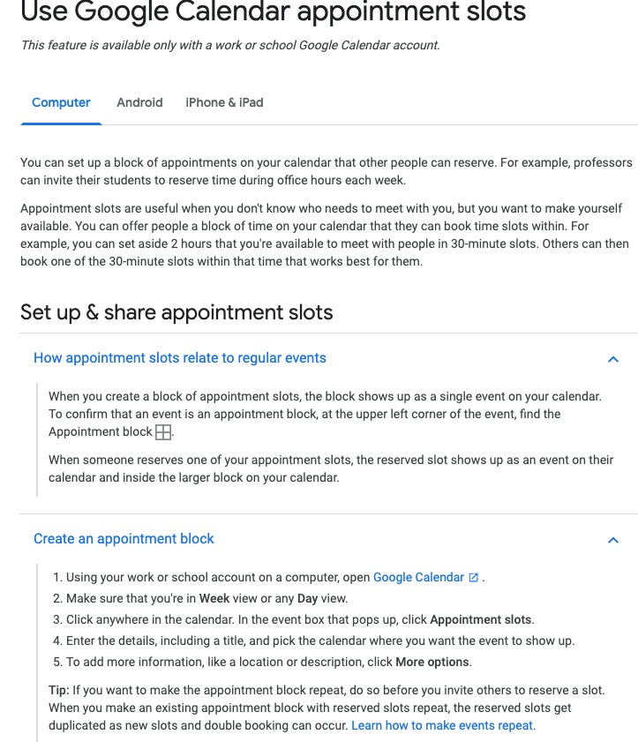
More information on Google "Appointment Slots" - HERE

