Institutional Factbook
The Factbook contains a wide variety of data relating to Fitchburg State University. Included is information on admissions, enrollment, degrees conferred, retention and graduation rates, faculty and staff, and finances.
If you have any questions or comments regarding the information contained in the Factbook, please contact:

Office of Institutional Research and Planning
160 Pearl Street
Fitchburg, MA 01420
irp@fitchburgstate.edu
(978) 665-3145

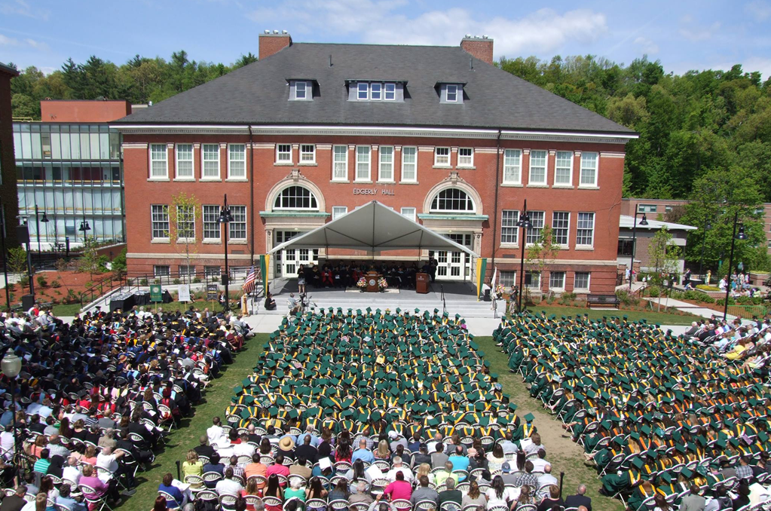

Contents
Admissions 4
New Undergraduate Students: Admissions Yield Five Years 5
New Undergrad Students: Gender, Race/Ethnicity Fall 2019 5
New Freshmen: SAT Distribution Fall 2019 6
New Freshmen: Top Feeder High Schools Fall 2019 7
New Transfer Students: Top Feeder Colleges Fall 2019 7
New Undergraduate Student Count: Five Years 8
New Undergraduate Students by Major Five Years 9
Enrollment 10
Undergraduate Students: Count, Full-time/Part-time, Gender Five Years 11
Undergraduate Students: Race/Ethnicity, Gender Fall 2019 11
Residence Hall Occupancy Five Years 12
Undergraduate Students by First Major Five Years 12
Undergraduate Students: Age Distribution Five Years 13
Undergraduate Students by Earned Credits Fall 2019 13
Annual Unduplicated Headcount Five Years 14
Annual FTE Five Years 14
Annual Registered Credits Five Years 14
Degrees Awarded 15
Degrees Awarded: Count, Race/Ethnicity, Gender: 2020 16
Degrees Awarded By Program Five Years 17
Degrees Awarded By Program Five Years 18
Retention Rates Five Years 19
Graduation Rates Five Years 19
Faculty, Administration and Staff 20
Full-time Employees Five Years 21
Full-time Employee: Gender Five Years 21
Full-time Employee: Race/Ethnicity Five Years 21
Full-time Faculty: Gender, Rank Five Years 22
Full-time Faculty: Rank, Tenure Five Years 22
University Finances 23
Undergraduate Tuition and Fees Five Years 24
Revenues Five Years 24
Expenditures Five Years 25

Admissions

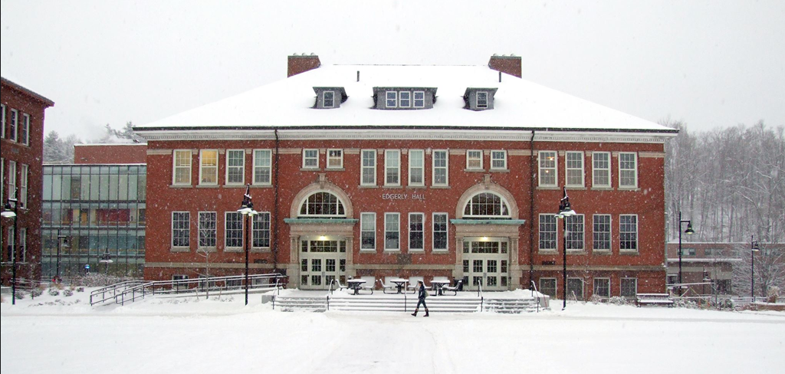
Fitchburg State University

New Undergraduate Students: Admissions Yield
 | Fall 2015 | Fall 2016 | Fall 2017 | Fall 2018 | Fall 2019
Applicants (completed application) | 4,638 | 4,224 | 4,279 | 3,861 | 3480
Accepted | 3,565 | 3,274 | 3,486 | 3,382 | 3103
Enrolled | 1,113 | 1,140 | 1,120 | 1,108 | 1014
Acceptance Rate | 76.9% | 77.5% | 81.5% | 87.6% | 89.2%
Yield Rate | 31.2% | 34.8% | 32.1% | 32.8% | 32.7%

Fitchburg State University

New Undergraduate Students: Gender, Race/Ethnicity

Fall 2019
Race or Ethnicity | First-time Freshmen |  |  | Transfers |  |  | All New Students
 | Male | Female | Total | Male | Female | Total | Male | Female | Total
Hispanic | 41 | 53 | 94 | 20 | 29 | 49 | 61 | 82 | 143
American Indian/Alaskan Native | 1 | 1 | 2 | 1 | 0 | 1 | 2 | 1 | 3
Asian | 16 | 10 | 26 | 7 | 2 | 9 | 23 | 12 | 35
Black or African-American | 36 | 43 | 79 | 22 | 19 | 41 | 58 | 62 | 120
Native Hawaiian/Pacific Islander | 0 | 0 | 0 | 0 | 0 | 0 | 0 | 0 | 0
White | 210 | 231 | 441 | 95 | 132 | 227 | 305 | 363 | 668
More than one | 9 | 16 | 25 | 2 | 6 | 8 | 11 | 22 | 33
Unspecified | 4 | 1 | 5 | 0 | 0 | 0 | 4 | 1 | 5
Non-resident Alien | 1 | 1 | 2 | 4 | 1 | 5 | 5 | 2 | 7
Total: | 318 | 356 | 674 | 151 | 189 | 340 | 469 | 545 | 1014

Fitchburg State University

New Freshmen: SAT Distribution

Fall 2019

Percent of first-time, first-year (freshman) students with scores in each range:
Score Range | Percentage in Range
> 1120 | 19.7
1081-1120 | 10.7
1041-1080 | 8.5
1001-1040 | 10.8
961-1000 | 8.3
920-960 | 4.5
<920 | 6.1
Did not submit SAT | 31.4

Fitchburg State University

New Freshmen: Top Feeder High Schools

Fall 2019
High School | Location
Montachusett Regional Vocational Technical High School | Fitchburg, MA
Leominster High School | Leominster, MA
Fitchburg High School | Fitchburg, MA
North Middlesex Regional High School | Townsend, MA
Oakmont Regional High School | Ashburnham, MA
Worcester Technical High School | Worcester, MA
Narragansett Regional High School | Baldwinville, MA
Nashoba Valley Technical High School | Westford, MA
North High School | Worcester, MA
Auburn High School | Auburn, MA
Gardner High School | Gardner, MA
Lawrence High School | Lawrence, MA
Ralph C. Mahar Regional High School | Orange, MA

Fitchburg State University

New Transfer Students: Top Feeder Colleges

Fall 2019
College | City
Mount Wachusett Community College | Gardner, MA
Quinsigamond Community College | Worcester, MA
Middlesex Community College | Lowell and Bedford, MA
Massachusetts Bay Community College | Wellesley Hills, MA
Worcester State University | Worcester, MA
Massasoit Community College | Brockton, MA
Bunker Hill Community College | Charlestown, MA
North Shore Community College | Lynn, MA

Fitchburg State University

New Undergraduate Student Count

 | Fall 2015 | Fall 2016 | Fall 2017 | Fall 2018 | Fall 2019
Freshmen | 790 | 763 | 757 | 715 | 674
Transfer | 323 | 377 | 365 | 393 | 340
Total | 1113 | 1140 | 1122 | 1108 | 1014

Fitchburg State University

New Undergraduate Students by Major

 | Fall 2015 | Fall 2016 | Fall 2017 | Fall 2018 | Fall 2019
Biology | 97 | 72 | 89 | 70 | 58
Business Administration | 113 | 124 | 125 | 125 | 122
Chemistry | 5 | 8 | 5 | 8 | 6
Communications/Media | 135 | 155 | 144 | 105 | 101
Computer Information Systems | 11 | 11 | 14 | 12 | 13
Computer Science | 43 | 36 | 39 | 37 | 29
Criminal Justice | 86 | 140 | 144 | 136 | 120
Early Childhood Ed. | 30 | 43 | 25 | 29 | 22
Economics | 2 | 8 | 2 | 6 | 5
Elementary Ed. | 34 | 34 | 42 | 31 | 41
English Studies | 22 | 25 | 20 | 15 | 14
Environmental and Earth Science | 6 | 3 | 7 | 8 | 8
Environmental and Public Health | - | - | - | - | 1
Exercise and Sport Science | 60 | 55 | 57 | 69 | 50
Game Design | 46 | 41 | 48 | 56 | 48
Geographic Science and Technology | 1 | 2 | 0 | 1 | 0
History | 14 | 18 | 21 | 15 | 7
Human Services | 19 | 19 | 25 | 22 | 9
Industrial Technology | 48 | 44 | 37 | 26 | 40
Interdisciplinary Studies | 8 | 14 | 9 | 16 | 6
Mathematics | 10 | 8 | 12 | 9 | 6
Middle School Ed. | 16 | 10 | 10 | 6 | 11
Nursing | 129 | 111 | 109 | 182 | 167
Political Science | 10 | 12 | 18 | 10 | 8
Psychological Sciences | 37 | 33 | 40 | 38 | 55
Sociology | 3 | 3 | 9 | 7 | 4
Special Ed. | 21 | 31 | 33 | 22 | 15
Technology Ed. | 3 | 4 | 2 | 1 | 3
Vocational Ed. | 14 | 6 | 12 | 8 | 9
Pre-major | 90 | 70 | 22 | 38 | 36
Total: | 1,113 | 1,140 | 1,120 | 1,108 | 1014

Enrollment

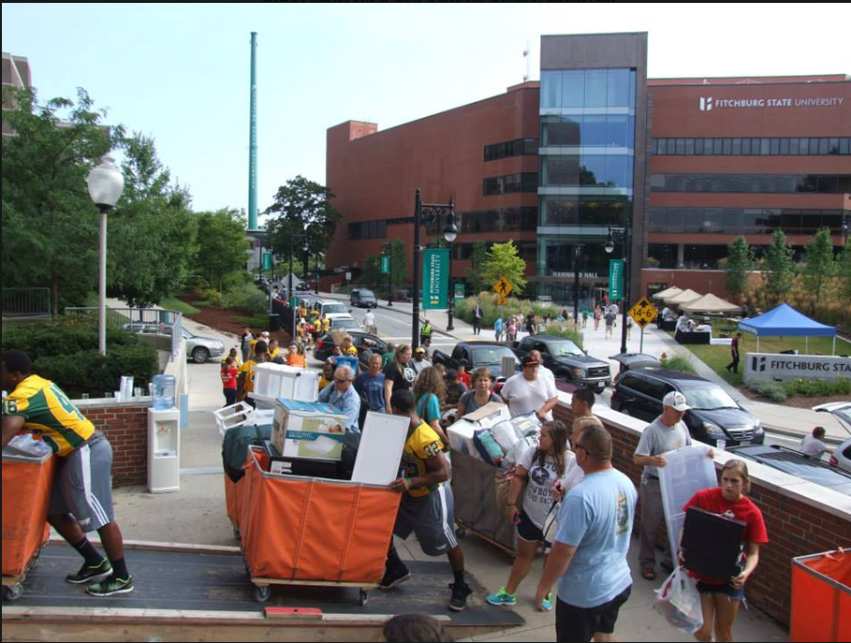

Fitchburg State University

Undergraduate Students: Count, Full-time/Part-time, Gender
 | Fall 2015 | Fall 2016 | Fall 2017 | Fall 2018 | Fall 2019
Headcount  Full-time Equivalent  Full-time  Part-time  Male  Female | 4,270  3,659.0  3,466 (81.2%)  804 (18.8%)  1,960 (45.9%)  2,310 (54.1%) | 4,162  3,622.7  3,428 (82.4%)  734 (17.6%)  1,955 (47.0%)  2,207 (53.0%) | 4,117  3,591.0  3,386 (82.2%)  731 (17.8%)  1,940 (47.1%)  2,177 (52.9%) | 4,163  3.570.5  3,319 (79.7%)  844 (20.3%)  1,954 (46.9%)  2,209 (53.1%) | 4,044  3.421.2  3,164 (78.2%)  880 (21.8%)  1,895 (46.9%)  2,149 (53.1%)

*Full-time Equivalent (“FTE”) is calculated at 15 credits per student.
*Full-time status is 12 or more credits/Part-time is less than 12 credits.

Fitchburg State University

Undergraduate Students, Race/Ethnicity, Gender

Fall 2019
 | Men | Women | Total
Non-resident Alien | 13 | 10 | 23 | 0.6 %
Black or African-American | 199 | 227 | 426 | 10.5 %
American Indian/Alaskan Native | 3 | 4 | 7 | 0.2 %
Hispanic or Latino | 209 | 291 | 500 | 12.4 %
White | 1315 | 1474 | 2789 | 69.0 %
Unknown | 30 | 16 | 46 | 1.1 %
Two or More | 66 | 80 | 146 | 3.6 %
Asian | 59 | 47 | 106 | 2.6 %
Native Hawaiian/Pacific Islander | 1 | 0 | 1 | -
Total: | 1895 | 2149 | 4044

Fitchburg State University

Residence Hall Occupancy
Fall 2015 | Fall 2016 | Fall 2017 | Fall 2018 | Fall 2019
1,694 | 1,630 | 1,680 | 1,558 | 1,405

Fitchburg State University

Undergraduate Students by First Major
 | Fall 2015 | Fall 2016 | Fall 2017 | Fall 2018 | Fall 2019
Biology | 279 | 259 | 258 | 248 | 210
Business Administration | 497 | 504 | 475 | 472 | 460
Chemistry | 12 | 25 | 23 | 26 | 23
Communications/Media | 524 | 514 | 496 | 455 | 410
Computer Info. Systems | 47 | 56 | 65 | 64 | 56
Computer Science | 102 | 91 | 95 | 101 | 104
Criminal Justice | 284 | 325 | 364 | 391 | 389
Early Childhood Education | 93 | 110 | 101 | 106 | 92
Economics | 9 | 16 | 19 | 19 | 13
Education Studies | - | - | - | - | 10
Elementary Education | 82 | 85 | 99 | 99 | 96
English Studies | 110 | 105 | 96 | 81 | 82
Environmental and Earth Science | 20 | 25 | 32 | 35 | 30
Environmental and Public Health | - | - | - | - | 4
Exercise and Sport Science | 241 | 220 | 187 | 195 | 172
Game Design | 117 | 138 | 162 | 174 | 166
Geographic Science and Technology | 7 | 9 | 8 | 8 | 8
History | 66 | 62 | 68 | 58 | 50
Human Services | 131 | 123 | 128 | 119 | 103
Industrial Technology | 189 | 183 | 165 | 141 | 136
Interdisciplinary Studies | 129 | 129 | 142 | 129 | 142
Mathematics | 40 | 41 | 41 | 32 | 26
Middle School Education | 34 | 38 | 30 | 25 | 28
Nursing | 444 | 394 | 390 | 484 | 505
Occupational/Vocational Education | 76 | 50 | 65 | 58 | 67
Political Science | 40 | 50 | 56 | 50 | 39
Pre-major | 99 | 78 | 60 | 68 | 83
Psychological Sciences | 181 | 190 | 195 | 188 | 191
Sociology | 30 | 26 | 25 | 33 | 28
Special Education | 111 | 100 | 88 | 81 | 63
Technology Education | 7 | 11 | 10 | 10 | 10
Vocational Technical | 15 | 8 | 9 | 5 | 11

Fitchburg State University

Undergraduate Students: Age Distribution
 | Fall 2015 | Fall 2016 | Fall 2017 | Fall 2018 | Fall 2019
< 18 | 124 | 87 | 66 | 79 | 59
18 - 19 | 1327 | 1374 | 1364 | 1295 | 1214
20 - 24 | 2097 | 2068 | 2060 | 2056 | 1984
25 – 34 | 374 | 342 | 320 | 361 | 380
35 – 44 | 170 | 161 | 147 | 188 | 203
45 – 54 | 139 | 97 | 117 | 136 | 151
55 - 64 | 35 | 29 | 37 | 42 | 47
> 65 | 1 | 3 | 5 | 6 | 6
Unknown | 3 | 1 | 1 | 0 | 0
Total: | 4270 | 4162 | 4117 | 4163 | 4044

Fitchburg State University

Undergraduate Students by Earned Credits

Fall 2019

90+ | 1,031
60-89 | 1,012
30-59 | 814
0-29 | 950
Non-degree | 237
Total: | 4,044

Fitchburg State University

Annual Unduplicated Headcount
(Fiscal Year, July 1 through June 30)
 | 2016 | 2017 | 2018 | 2019 | 2020
Undergraduate | 4,844 | 4,765 | 4,794 | 4,880 | 4,813
Graduate | 6,520 | 6,643 | 6,672 | 6,216 | 5,937
Both | 24 | 26 | 30 | 34 | 43
Total | 11,388 | 11,434 | 11,496 | 11,130 | 10,793

Fitchburg State University

Annual FTE
(Fiscal Year, July 1 through June 30)
 | 2016 | 2017 | 2018 | 2019 | 2020
Undergraduate | 3,688.6 | 3,681.4 | 3,645.2 | 3,631.0 | 3,471.1
Graduate | 1,433.8 | 1,488.8 | 1,739.8 | 1,582.0 | 1,895.3
Both | 12.5 | 19.5 | 25.3 | 29.4 | 31.5
Total | 5,134.8 | 5,189.7 | 5,410.2 | 5,512.4 | 5,397.9

Fitchburg State University

Annual Registered Credits
(Fiscal Year, July 1 through June 30)
 | 2016 | 2017 | 2018 | 2019 | 2020
Undergraduate | 110,657 | 110,442 | 109,356 | 108,930 | 104,134
Graduate | 34,410 | 35,731 | 41,754 | 44,448 | 45,487
Both | 346 | 551 | 697 | 816 | 875
Total | 145,413 | 146,724 | 151,807 | 154,194 | 150,496

Degrees Awarded

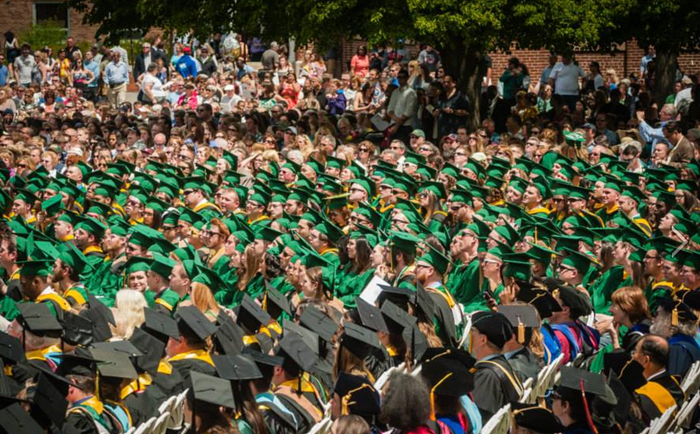

Fitchburg State University

Degrees Awarded: Count, Race/Ethnicity, Gender

2020
(Fiscal Year, July 1 through June 30)

 | Nonresident alien | Hispanic Latino | American Indian or Alaska Native | Asian | Black or African American | Native Hawaiian or Other Pacific Islander | White | Two or more Races | Race/ ethnicity unknown | Total
Bachelor’s degree
Men | 1 | 30 | 0 | 7 | 35 | 1 | 287 | 13 | 9 | 383
Women | 1 | 54 | 0 | 7 | 45 | 0 | 370 | 17 | 4 | 498
Total | 2 | 84 | 0 | 14 | 80 | 1 | 657 | 30 | 13 | 881
Post-Baccalaureate certificates
Men | 0 | 0 | 0 | 0 | 0 | 0 | 3 | 0 | 0 | 3
Women | 0 | 1 | 0 | 0 | 0 | 0 | 12 | 0 | 0 | 13
Total | 0 | 1 | 0 | 0 | 0 | 0 | 15 | 0 | 0 | 16
Master's degree
Men | 15 | 20 | 0 | 15 | 15 | 0 | 201 | 4 | 8 | 278
Women | 14 | 38 | 0 | 19 | 37 | 0 | 437 | 9 | 17 | 571
Total | 29 | 58 | 0 | 34 | 52 | 0 | 638 | 13 | 25 | 849
Post-Master's certificates
Men | 0 | 0 | 0 | 0 | 1 | 0 | 3 | 0 | 0 | 4
Women | 0 | 0 | 0 | 0 | 0 | 0 | 15 | 0 | 0 | 15
Total | 0 | 0 | 0 | 0 | 1 | 0 | 18 | 0 | 0 | 19
Grand Total Men | 16 | 50 | 0 | 22 | 51 | 1 | 494 | 17 | 17 | 668
Grand Total Women | 15 | 93 | 0 | 26 | 82 | 0 | 834 | 26 | 21 | 1097
Grand Total | 31 | 143 | 0 | 48 | 133 | 1 | 1328 | 43 | 38 | 1765

Fitchburg State University

Undergraduate Degrees Awarded By Program
(July 1 through June 30)

 | 2016 | 2017 | 2018 | 2019 | 2020
B.A. Biology | 0 | 0 | 3 | 2 | 7
B.A. English Studies | 6 | 3 | 7 | 3 | 6
B.A. History | 3 | 3 | 1 | 1 | 0
B.A. Interdisciplinary Studies | 2 | 1 | 1 | 1 | 2
B.A. Mathematics | 0 | 0 | 0 | 0 | 1
B.A. Political Science | 0 | 0 | 0 | 1 | 0
B.A. Psychological Sciences | 0 | 0 | 0 | 0 | 1
B.A. Sociology | 0 | 1 | 0 | 3 | 0
B.S. Biology | 39 | 53 | 49 | 49 | 41
B.S. Business Administration | 108 | 114 | 98 | 92 | 106
B.S. Chemistry | 0 | 1 | 6 | 4 | 6
B.S. Communications/Media | 116 | 137 | 108 | 102 | 113
B.S. Computer Information Systems | 12 | 11 | 13 | 16 | 18
B.S. Computer Science | 8 | 11 | 8 | 9 | 14
B.S. Criminal Justice | 63 | 59 | 57 | 54 | 76
B.S. Earth Science | 4 | 1 | 8 | 5 | 15
B.S. Economics | 6 | 3 | 7 | 4 | 2
B.S. Educational Studies | - | - | - | - | 2
B.S. English Studies | 23 | 21 | 17 | 19 | 23
B.S. Exercise and Sport Science | 41 | 68 | 50 | 34 | 40
B.S. Game Design | 10 | 19 | 26 | 27 | 38
B.S. Geography | 2 | 3 | 3 | 3 | 4
B.S. History | 13 | 15 | 10 | 13 | 14
B.S. Human Services | 39 | 38 | 35 | 31 | 38
B.S. Industrial Technology | 37 | 49 | 25 | 42 | 20
B.S. Interdisciplinary Studies | 57 | 64 | 82 | 65 | 71
B.S. Mathematics | 9 | 9 | 10 | 5 | 7
B.S. Nursing | 106 | 90 | 88 | 92 | 102
B.S. Occupational/Vocational Educ. | 11 | 5 | 12 | 12 | 7
B.S. Political Science | 8 | 3 | 9 | 13 | 14
B.S. Psychological Sciences | 40 | 44 | 47 | 44 | 36
B.S. Sociology | 6 | 10 | 7 | 5 | 9
B.S.E. Early Childhood Education | 3 | 8 | 14 | 15 | 18
B.S.E. Elementary Education | 8 | 5 | 12 | 9 | 14
B.S.E. Middle School Education | 4 | 5 | 2 | 1 | 6
B.S.E. Special Education | 21 | 8 | 6 | 6 | 9
B.S.E. Technology Education | 2 | 0 | 0 | 1 | 1
Total: | 807 | 862 | 821 | 783 | 881

Fitchburg State University

Graduate Degrees Awarded By Program
(July 1 through June 30)

 | 2016 | 2017 | 2018 | 2019 | 2020
Masters
M.A. Biology | 1 | 1 | 1 | 1 | 1
M.A. English | 13 | 4 | 2 | 1 | 5
M.A. History | 3 | 1 | 4 | 3 | 0
M.A.T. Biology | 3 | 3 | 2 | 1 | 1
M.A.T. English | 8 | 1 | 4 | 1 | 9
M.A.T. History | 1 | 0 | 4 | 1 | 0
M.S. Communications | 7 | 18 | 8 | 3 | 3
M.S. Computer Science | 21 | 33 | 21 | 23 | 16
M.S. Counseling | 10 | 13 | 17 | 14 | 18
M.S. Criminal Justice | - | - | - | 3 | 7
M.S. Forensic Nursing | 4 | 8 | 10 | 9 | 5
M.Ed. Arts Education | 5 | 4 | 2 | 2 | 3
M.Ed. Curriculum and Teaching | 142 | 131 | 134 | 168 | 165
M.Ed. Early Childhood Education | 9 | 7 | 13 | 11 | 8
M.Ed. Education Leadership and Management | 6 | 5 | 2 | 4 | 25
M.Ed. Elementary Education | 6 | 9 | 11 | 8 | 5
M.Ed. Middle School Education | 7 | 5 | 6 | 1 | 2
M.Ed. 5-12 | - | - | - | - | 7
M.Ed. Occupational Education | 18 | 17 | 9 | 4 | 8
M.Ed. Science Education | 1 | 5 | 0 | 1 | 4
M.Ed. Secondary Education | 3 | 0 | 0 | 0 | 0
M.Ed. Special Education | 52 | 61 | 86 | 106 | 118
M.Ed. Technology Education | 3 | 3 | 2 | 0 | 0
M.B.A., Master of Business Administration | 48 | 56 | 88 | 319 | 439
Total Masters: | 371 | 385 | 426 | 684 | 849
Certificates of Advanced
Graduate Study
C.A.G.S. Education Leadership and Management | 4 | 8 | 7 | 14 | 14
C.A.G.S. Interdisciplinary Studies | 15 | 12 | 12 | 8 | 5
Total C.A.G.S.: | 19 | 20 | 19 | 22 | 19

Fitchburg State University

Retention Rates
(First-time, full-time freshmen)
Cohort Year | 2014 | 2015 | 2016 | 2017 | 2018 | 5-Year
Number in Cohort | 720 | 781 | 759 | 751 | 713 | 3,724
Number Retained Following Fall | 540 | 587 | 595 | 551 | 525 | 2,798
Retention Rate | 75.0% | 75.2% | 78.4% | 73.4% | 73.6% | 75.1%

Fitchburg State University

Six Year Graduation Rates
(First-time, full-time freshmen)
Cohort Year | 2009 | 2010 | 2011 | 2012 | 2013 | 5-Year
Number in Cohort | 781 | 721 | 689 | 738 | 790 | 3,719
Number Graduating Within 6 Years | 414 | 389 | 411 | 450 | 456 | 2,120
Graduation Rate | 53.01% | 53.95% | 59.65% | 60.97% | 57.72% | 57.00%

Faculty, Administration and Staff

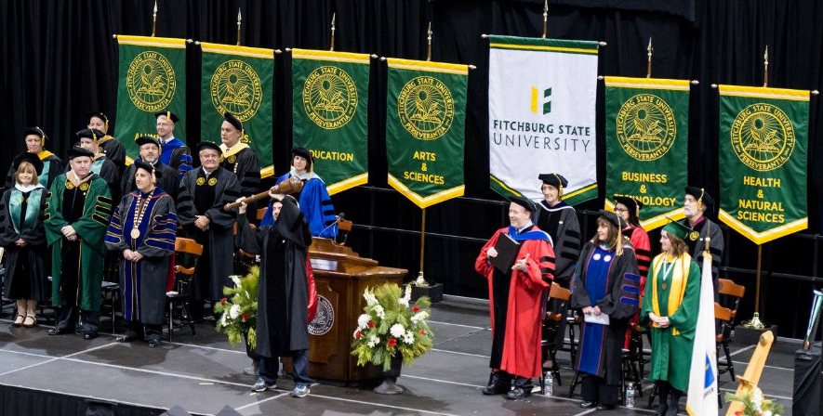

Fitchburg State University

Full-time Employees
 | Fall 2015 | Fall 2016 | Fall 2017 | Fall 2018 | Fall 2019
Faculty | 204 | 204 | 203 | 200 | 206
Staff | 347 | 311 | 309 | 336 | 346
Total | 551 | 515 | 512 | 536 | 552

Fitchburg State University

Full-time Employee by Gender
 | Fall 2015 | Fall 2016 | Fall 2017 | Fall 2018 | Fall 2019
Male | 258 | 246 | 235 | 238 | 243
Female | 293 | 269 | 277 | 298 | 309
Total: | 551 | 515 | 512 | 536 | 552

Fitchburg State University

Full-time Employee by Race/Ethnicity
 | Fall 2015 | Fall 2016 | Fall 2017 | Fall 2018 | Fall 2019
American Indian/Alaskan Native | 2 | 0 | 0 | 0 | 0
Asian | 16 | 16 | 17 | 22 | 25
Black or African American | 15 | 14 | 14 | 21 | 24
Hispanic | 11 | 13 | 19 | 23 | 28
Native Hawaiian or other Pacific Islander | 0 | 0 | 0 | 1 | 1
White | 499 | 463 | 454 | 468 | 473
More Than One | 6 | 9 | 8 | 0 | 0
Non-resident Alien | 0 | 0 | 0 | 0 | 0
Unknown | 2 | 0 | 0 | 1 | 1
Total: | 551 | 515 | 512 | 536 | 552

Fitchburg State University

Full-time Faculty: Gender, Rank
 | Fall 2015 |  |  | Fall 2016 |  |  | Fall 2017 |  |  | Fall 2018 |  |  | Fall 2019
 | Male | Male | Female | Total | Female | Total | Male | Female | Total | Male | Female | Total | Male | Female | Total
Professor | 50 | 24 | 74 | 44 | 23 | 67 | 42 | 28 | 70 | 43 | 28 | 71 | 42 | 28 | 70
Assoc. Professor | 27 | 27 | 54 | 27 | 26 | 53 | 30 | 29 | 59 | 27 | 35 | 62 | 32 | 34 | 66
Assist. Professor | 33 | 40 | 73 | 36 | 42 | 78 | 31 | 33 | 64 | 31 | 30 | 61 | 23 | 37 | 60
Instructor | 0 | 3 | 3 | 0 | 6 | 6 | 3 | 7 | 10 | 0 | 6 | 6 | 1 | 9 | 10
Total: | 110 | 94 | 204 | 107 | 97 | 204 | 106 | 97 | 203 | 101 | 99 | 200 | 98 | 108 | 216

Fitchburg State University

Full-time Faculty, Tenure, Rank
 | Fall 2015 |  |  | Fall 2016 |  |  | Fall 2017 |  |  | Fall 2018 |  |  | Fall 2019
 | Tenure | Non-tenure | Total | Tenure | Non-tenure | Total | Tenure | Non-  Tenure | Total | Tenure | Non-Tenure | Total | Tenure | Non-Tenure | Total
Professor | 72 | 2 | 74 | 67 | 0 | 67 | 70 | 0 | 70 | 71 | 0 | 71 | 70 | 0 | 70
Assoc. Professor | 54 | 0 | 54 | 50 | 3 | 53 | 50 | 3 | 53 | 58 | 4 | 62 | 59 | 7 | 66
Assist. Professor | 1 | 65 | 66 | 1 | 71 | 72 | 1 | 62 | 63 | 1 | 60 | 61 | 0 | 60 | 60
Instructor | 0 | 10 | 10 | 0 | 12 | 12 | 3 | 14 | 17 | 0 | 6 | 6 | 0 | 10 | 10
Total: | 127 | 77 | 204 | 118 | 86 | 204 | 124 | 79 | 203 | 130 | 70 | 200 | 129 | 77 | 206

University Finances

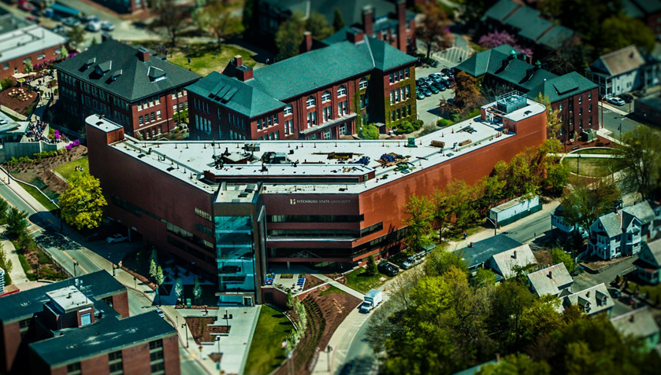

Fitchburg State University

Undergraduate Tuition and Fees
Annual Day-school in-state student charges
Academic Year | Tuition and Fees
2015 - 2016 | $9,935
2016 - 2017 | $10,135
2017 - 2018 | $10,175
2018 – 2019 | $10,405
2019 - 2020 | $10,555

Fitchburg State University

Revenues
(Fiscal Year July 1 – June 30)
 | FY 2015 | FY 2016 | FY 2017 | FY 2018 | FY 2019
Tuition and Fees | $31,651,220. | $34,192,551. | $36,762,378. | $39,528,610 | $41,989,830
State Appropriations | $36,197,548. | $37,159,087. | $38,873,231. | $39,403,569 | $43,794,742
Federal Operating  Grants and Contracts | $1,093,842. | $1,158,346. | $935,421. | $776,751 | $952,747
State Operating  Grants and Contracts | $2,697,878. | $2,664,528. | $2,570,582. | $2,694,582 | $2,762,514
Local and Private Operating  Grants and Contracts | $449,397. | $491,587. | $612,995. | $1,217,353 | $980,662
Sales and Services of  Auxiliary Enterprises | $9,444,114. | $9,430,318. | $9,805,413. | $10,824,177 | $15,066,730
Other | 9,002,929. | $9,122,072. | $10,067,456. | $10,867,766 | $10,903,765
Total: | $90,536,928. | $94,218,489. | $99,627,476. | $105,312,808 | $116,450,990

Fitchburg State University

Expenditures
(Fiscal Year July 1 – June 30)
 | FY 2015 | FY 2016 | FY 2017 | FY 2018 | FY 2019
Instruction | $43,833,015. | $45,616,516. | $49,013,180. | $49,271,372 | $50,818,499
Research | $1,373. | $2,816. | $12,339. | $120,071 | $106,694
Public Service | $506,954. | $599,972. | $631,869. | $673,502 | $1,045,002
Academic Support | $7,399,835. | $8,175,098. | $8,468,627. | $9,570,580 | $11,348,998
Student Services | $14,013,929. | $14,076,890. | $14,536,879. | $14,885,496 | $19,023,660
Institutional Support | $10,775,651. | $13,006,204. | $14,433,157. | $15,111,677 | $14,385,211
Scholarship and Fellowships | $2,056,995. | $2,148,658. | $2,346,313. | $3,041,550 | $3,238,869
Auxiliary Enterprises | $9,466,890. | $9,211,394. | $9,971,565. | $10,865,020 | 15,631,433
Other Expenses and Deductions | $1,376,109. | $0.00 | $0.00 | $0.00 | $1,847,476
Total: | $89,430,751. | $92,837,548. | $99,413,929. | $103,539,268 | $117,445,842

