To the campus community,
I am writing to notify all of you that we will soon start preparations for our ten-year comprehensive regional accreditation by the New England Commission of Higher Education (NECHE). This process will center on the writing of a thorough self-study document in which we tell our institutional story, describing the good work we do and how it adheres to NECHE’s nine accreditation standards, while also demonstrating our unceasing commitment to continuous improvement.
It is my pleasure to announce that our accreditation efforts will be co-chaired by Associate Vice President for Academic Affairs Cathy Canney and Professor Daneen Deptula from our Behavioral Sciences Department.
Soon we will be seeking volunteers from across the campus to form committees, with their critical work beginning at the start of the fall 2020 semester. The self-study will be performed by these committees focused on each of the accreditation standards, with draft reports being produced during the fall and spring semesters. The process will include opportunities for all stakeholder voices through such mechanisms as surveys and open forums. By fall 2021, our final draft self-study will be shared through university governance and the Board of Trustees. The final report will be submitted to NECHE in spring 2022, when the accreditation team visits campus for its review. Be assured we will keep you notified of each step in this process. The NECHE site visit is confirmed for March 20-23, 2022.
I encourage all members of our campus to get involved in this vital effort that will contribute to an even stronger Fitchburg State University.
Sincerely,
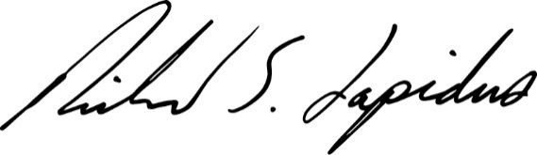

Richard S. Lapidus, President

