How to identify advisees in SSC that have not yet registered for the upcoming semester:
Click the Show Advanced Filters box in the upper right hand corner of the Search page and open the Student Information and Enrollment History sections. Under Student Information, expand the Category options by clicking the + sign and select the Applied to Graduate category under the Category (In None of these) option. This will exclude students that have applied to graduate.
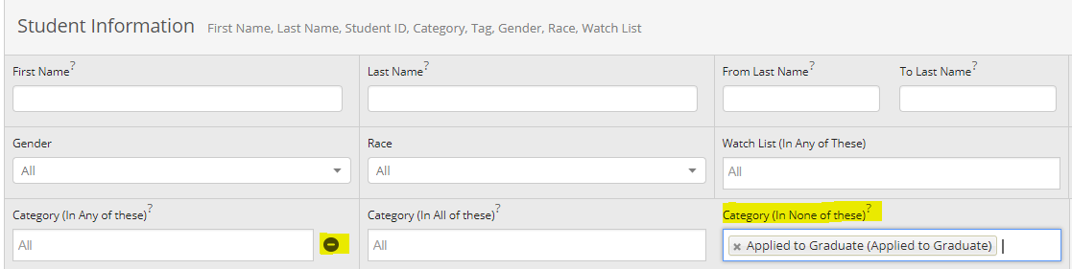
Under the Enrollment History section, enter the current term in the Enrollment Terms (In Any of these), expand the options by clicking on the + sign, and enter the upcoming term in the Enrollment Term (In None of these) field.
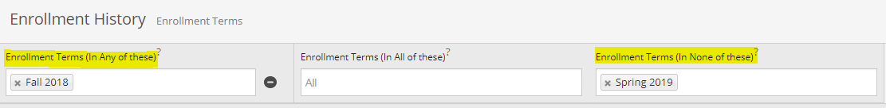
Scroll down and click the My Students Only box. This will limit the search to your advisees. Click the Search button and your unregistered students will display.
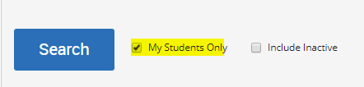
If you want to exclude students that have a registration hold, you can add the HOLD category in the Category (In None of these) field, along with the Applied to Graduate group.
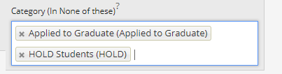

Questions? ssc@fitchburgstate.edu

